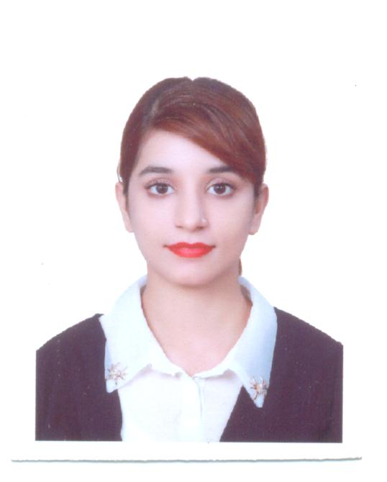
Farwa
Farwa.351224@2freemail.com

Personal Profile

A competent, talented, well-educated of the professional work environment, quick to learn & used to working under pressure & meeting deadlines. A flexible practical person trained in analytical methods, seeking career within a management or a professional environment.

Profile Statement

An Energetic, reliable and detail-oriented professional with over 6 years’ experience in the areas of Hospitality, Sales, Customer Services and Administration with a proven track record of achievements in a competitive environment. Confident, and committed to professional standards who is able to multi task handle pressure, work as part of a team and most importantly help out the customers to ensure they receive an excellent level of service whilst at the same time ensuring the highest level of sales for the company.

Key Result Areas

Customer Relationship Management:
I can sustain a sound relationship with existing clientele Quantify client requirements through close contact.
Customer Service:
I have always maintained high standards of service levels to all my customers since I thoroughly believe in a long term relationship professionally.
Administration/Time Management:
Managing a team of employees makes me proficient on my time management thereby setting an example within the organization & relevant teams.
Multi-Tasking:
Given a high pressure job, I can very easily handle more than one task at a time without any display of frustration.
Selling Skills:
I can negotiate to sell anything that is presented to me. My adaptation in any product is very powerful.

Professional Background

London Crown Hotel
DUBAI, UAE
(DEC 2016 -Present date)

Position: Front Desk Officer

Undertook front of house duties, including meeting , greeting and attending the needs of guests, to ensure a superb customer service experience
Built a good rapport with all guests and resolve any complaints/issues quickly to maintain high quality customer service
Responsible for accurate and efficient accounts and guest billing process
Assisted in keeping the hotel reception clean and tidy at all times
Undertook general office duties, including correspondences, emails, filling and switch board, to ensure the smooth running of the reception area
Administered all routes of reservations (e.g. online, phone) to ensure that room bookings are made and recorded accurately and ensure all reservation and cancellations are processed efficiently
Keep up to date with room prices and special offers to provide accurate information to guests.

COSH INTERNATIONAL
Sialkot, Pakistan
(Jan 2016 – Oct 2016)

Position: Office Manager

Handling the staff.
Answered telephonic and in-person queries related to COSH services and resolved any issues.
Check the ready to ship order.
Doing all follow ups and make sure that order should be ready on time.
Liaised with other departments of COSH.
Handling payments through Credit cards, Bank transfer, Pay pal, WU.
Making Payrolls And Handling All Expenses Of the Month.

HOTEL THE JEEVENS
Sialkot, Pakistan
(Jan 2015 - Dec 2015)

Position: Front Desk Officer

Serve Visitors by Greeting, Welcoming, Directing and announcing them appropriately
Answer, Screen and forward any incoming phone calls while providing basic information when needed
Receive and short daily mails/deliveries/couriers
Maintain security by following procedures and controlling access (Monitor, logbooks, Issue visitor badges)
Update appointment calendars and schedule meeting/appointments
Perform other clerical receptionist duties such as filing, photocopying, collating faxing etc.

Education

I.C.S (Computer Science)

Technical Skills

Good knowledge of Windows.
Good knowledge of MS Word.
Good knowledge of MS Excel.
Good knowledge of Internet.
Good Knowledge of IDS and PRD.

Managerial Skills

Capable of working well under pressure.
Ability of handling multiple tasks.
Excellent communication power.
Able to finish the work in lesser and targeted time.
Good interpersonal skills.
Knows how to perform different tasks by time management.
Disciplined and cultured life attitude.

Language Proficiency

English: Excellent
Urdu: Native
Hindi: Excellent
Arabic: Normal

Interests

Book Reading
Traveling around the world.
I enjoy socializing, meeting people & learning about different backgrounds & cultures.
I also take a keen interest of what’s happening around the world.

Reference

Reference can be established upon demand.

