PROJECT COORDINATOR/SITE ENGINEER 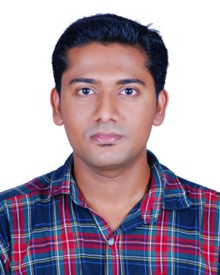
SABARINATH
SABARINATH.351247@2freemail.com

CAREER OBJECTIVE
Dedicate, energetic and motivated team player seeking a career that would help me to develop my extensive skills and also utilize the same for the growth of the company.

PROFESSIONAL EXPERIENCE

Working as Project Coordinator/Site Engineer at Tectronics W.L.L, Abu Dhabi. (from10th February 2015 to present).

RESPONSIBILITIES

- Estimates prepare and assign the resources such as manpower, materials, consumables, equipment and tools etc.
- Plans and analyses all possible construction methodologies and recommends the best options to the Project Manager for approval prior to execution at site.
- Responsible for design review & implementation of suitable solutions of Lighting Systems.
- Installation, Testing and Commissioning of Lighting systems such as Grandar and DMX Systems.
- Submits site daily reports, inspection requests, and all applicable monitoring reports on regular basis or as required and maintaining in proper database.
- Ensures that all the works done are in accordance with the approved construction drawings, project specifications, and all applicable standards whether local, national or international Standards.
- Responsible for Training and Final Handing Over to Client.

PROJECTS WORKED

- ADNOQ HQ - Lighting Systems - Abu Dhabi, UAE
- SARAYA RESIDENTIAL TOWER - Lighting systems - Abu Dhabi , UAE
- WORLD TRADE CENTER – Lighting Systems- Abu Dhabi ,UAE

PROFESSIONAL SUMMARY

- Currently working in AV and Lighting System based company in Abu Dhabi, UAE.
- Managing and maintaining the commissioning & execution of Lighting Systems.
- Able to execute system integration techniques for various Electronic systems.
- Possess good Communication and Documentation Skills
ACADEMIC QUALIFICATION

Bachelor of Engineering (B.E) in Electronics and Communication Engineering
Anna University, Tamil Nadu, India - (Sep 2008- June 2012)

PROFESSIONAL COURSES

- CCNA ( Routing and Switching)
- CCNP ( Routing and Switching)

HOBBIES AND INTERESTS

- Reading Books
- Listening Music

DECLARATION
I hereby declare that all the statements made in this resume are true, complete and correct to the best of my knowledge and belief.

