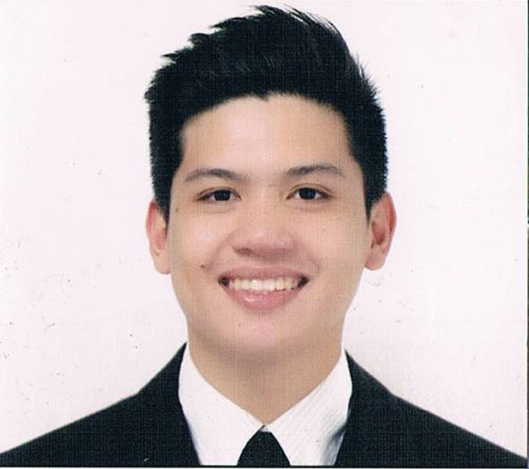
JOHN
John.351262@2freemail.com

OBJECTIVE:

To have a career in a company where I would be able to maximize my potential, knowledge, accept organizational challenge. Explore new skill that will contribute to the company’s growth while mutually improving my career as well and prove to be an asset functioning effectively
EDUCATIONAL BACKGROUND:

Bachelor of Science in Hotel and Restaurant Management
Tarlac State University
APRIL 2015

WORK EXPERIENCES
BARISTA  STARBUCKS (Philippines)  (January 2016-February 2017) | Duties and Responsibilities:  - Communicate with customers, note their preferences and take feedback  - Perform cashiering and inventory management tasks  - Greet customers as they arrive at the Starbucks outlet and inquire into their orders  Provide customers with information on popular coffee blends  - Brew coffee per instructions while ensuring that each brew conforms to the standards set by Starbucks  - Ensure that Starbucks merchandising and signing standards are followed appropriately
SERVER/DOUGH MASTER/ CASHIER  PIZZA HUT (PHILIPPINES)  (June 2015-November 2015) | - Greet customers, take orders, assemble orders and receive payments  - Backing up other team members during weekends and holidays  - Prepare all raw materials required for cooking such  as cutting all vegetables and preparing dough.  - Provide initial training to new team members  - Maintain neat eating and serving areas
Customer Service Assistant cum Cashiering  -Maxs Restaurant Philippines  (October 2014-March 2015) | - Handle cash transactions with customers  - Resolve customer complaints, guide them and provide relevant information  - Pleasantly deal with customers to ensure satisfaction  - Taking payments by cash, cheque or credit card.  - Booking and processing reservation

SKILLS AND KNOWLEDGE:
- Excellent communication and guest/employee relations skills.
- Excellent proactive attitude to work.
- Proven track record in delivering quality dining service.
• Excellent communication and customer service skills
• Friendly mannerism
• Ability to work efficiently without supervision
- Great ability to promote excellent quality, customer service and cleanliness

AWARDS AND RECOGNITIONS:

ACTUAL SHIPBOARDTRAINING
Conducted from April 4 to 6, 2014
Onboard M/V ST. LEO THE GREAT, Philippines

Best Top Grossing in Sales
Given this 23rd day of April, 2014
Tarlac State University main AVR, Tarlac City, Philippines

Best Group for Shipboard Apprentice Experience
Given this 23rd day of April, 2014
Tarlac State University main AVR, Tarlac City, Philippines

SEMINAR AND TRAINING EXPERIENCE:

Front Office cum Receptionist
Central Park Hotel Philippines

Server cum Cook
Max’s Restaurant Tarlac City, Philippines

OCEANLINK INSTITUTE, INC.
ACTUAL SHIPBOARD TRAINING
Conducted from April 4 to 6, 2014
Onboard M/V ST. LEO THE GREAT, Philippines

HOTEL FAMILIARIZATION AND OVERVIEW OF HOTELS OPERATIONS
Given this 30th day of January 2012
Hotel Supreme, Baguio City, Philippines

PERSONAL INFORMATION
Age: 23 years of age
Birthday : September 30,1993
Height : 5’7
Language: Fluent in English and Basic Chinese

I hereby certify that the above information is true and correct to the best of my knowledge and belief.

Dear HR Manager,
A successful consultative person has the ability to develop and nurture long – term relationships. My success in this area is well documented. My customers will tell you I am efficient and organized; a helpful person with a superior follow – through; and excellent at building rapport and fostering mutually beneficial relationships. My supervisors look at the bottom line and acknowledge my overall contributions to the company.

Although my enclosed resume is practical in nature, it cannot convey the full level of my eagerness to undertake new challenges. I would like to continue my successful growth in the field and enthusiasm in all my endeavors.

I know I will make a positive contribution to your company, and look forward to discussing my capabilities in more detail. I am available for an interview at your convenience. I know you are busy, and have many applications to review, so please let me know if you wish to further discuss your requirements and my ability to meet them. Thank you for your time and consideration.

