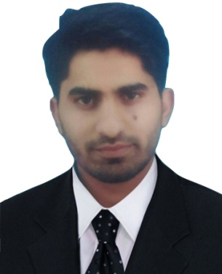
RANA
Rana.351306@2freemail.com

Objective: Seeking a Long Term Career with a leading organization to enhance my skills and experience in the field of Human Resource and Services.
Key Skills: HRMS, Record keeping, Letter writing, Communications, Solution focused, Strong process and system handling.

Professional Experiences:

Organization: Pakistan Telecommunication Authority
Designation: Management Trainee Officer Human Resource (Contract)
Period: August 2016 – February 2017
Location: Islamabad, Pakistan

Job Summary
Responsible for working alongside managers and accepting delegated responsibilities and duties with the goal of eventually becoming a manager.

Job Profile:
- Assisting Human Resource Manager
- Work in different departments to gain perspective, including customer services, Administration, Government and External Affairs, and other departments.
- Work with other managers to plan and direct the work of the organization.
- Assisting employees with leave queries, managing and monitoring their leave applications through Leave Tracking Database
- Maintain diary, arrange meetings and appointments and provide reminders
- Work enthusiastically in preparing letters, salary certificates, experience letters etc. for employees in a timely and accurate manner
- Maintain centrally organized record of employee’s personal file, update records and documents for all employees and also scheduling of meetings, interviews with candidates.
- Be familiar with all HR Policies and provide accurate advice to employees.
- Salary, Leave Salary Calculations. Assisting in Payroll.
- Data entry (Employee record).
- HRMIS reporting and other related assignments.
Key Competencies
- verbal and written communication skills
- problem analysis and problem solving
- organizational skills
- attention to detail
- judgment
- adaptability
- team work
Profile:
- Preparation of payroll and Salary
- Basic training related to Human Resource Management.
- Maintaining of Human Resource files & archives

Education:
- MBA (Human Resource Management), CGPA 3.5/4 –Preston University Islamabad, Pakistan. 2016
- B.com - University of the Punjab, Pakistan. 2010

Other Skills:
- Computer Skills: HRMS (Intermediate Level), Word, Advance Excel, Outlook.
- Languages: English, Urdu, Hindi, Punjabi.

