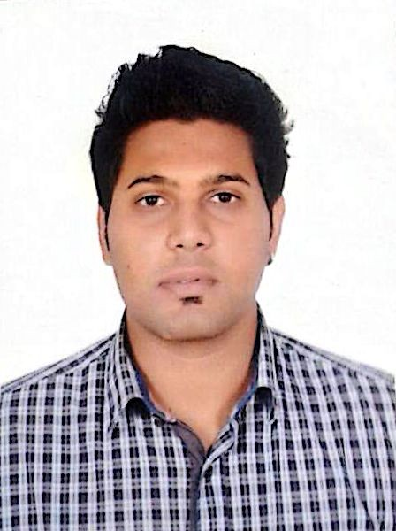
Asad
Email: asad.351377@2freemail.com

Education

Sep 2012 University of Ottawa, Ottawa, Canada.
Apr 2014 Major: Mechanical Engineering – Bachelor of Science.

- Relevant Courses: 3D Design, AutoCAD, C++ coding & SolidWorks.
- Knowledge of advanced calculus and linear algebra.

Nov 2010- Oxford College of Canada, Toronto, Canada.
Jun 2012 Ontario Secondary School Diploma (OSSD) approved by Ontario Ministry of Education.

- Courses include: Physics, Chemistry, Biology, Advanced Functions, Business Studies and Linear Algebra.

Work Experience

Jan 2017- Etisalat, Dubai UAE
Current Sales Executive through Channel Partner Sharaf DG

- Achieved monthly sales targets.
- Visited companies and offices to build and maintain client relations.
- Created and closed successful leads.
- Informed clients about different packages/promotions.
- Formulated Daily Sales Reports.
- Successfully completed Etisalat E-Training

Jul 2016- Abtco LLC, Dubai, UAE
Dec 2016 Merchandiser at Hyper Panda

- Achieved monthly sales targets.
- Singlehandedly set up and conducted product promotions.
- Assisted customers with the products they were looking for with superior customer service.
- Ensured accurate inventory ordering and shelving is complete in a timely manner.
- Supported creating monthly sales report.

Sep 2013- Gabriel Pizza, Ottawa, Canada
Feb 2014 Food Services Assistant.

- Successfully conducted day-to-day transactions with cash, debit or credit card.
- Provided highest quality of customer service.
- Assisted with opening and closing duties.

Jul 2013- University of Ottawa, Ottawa, Canada
Feb 2014 Library Assistant at Morisset Library.

- Helped customers with their queries about the library and its resources.
- Organized and reserved study rooms for students.
- Communicated with customers about their book issues and return deadlines in an orderly manner.

Dec 2012- Mr. Sub, Ottawa, Canada
Jul 2013 Food Services Assistant.

- Operated POS with high precision and transactions involving cash, debit or credit card.
- Completed customers’ orders to their utmost satisfaction.
- Successfully operated machinery.

Leadership Roles

Sep 2012- University of Ottawa, Ottawa, Canada
Apr 2014 Active member of Pakistani Student Association.
- Organized charity events to create cultural awareness amongst the community.
- Organized interuniversity sport events.
- Distributed food and water during the Holy Month of Ramadan in community mosque.
Jan 2011- Toronto, Canada
Jun 2012 Volunteer of Toronto City and Greater Toronto Area (GTA).
- Organized charity events to raise funds for disabled members of the community.

Honours and Awards

Jan 2014 University of Ottawa, Ottawa, Canada
- Awarded 1st runner up position for interuniversity cricket competition.
- Awarded 2nd runner up position for ice hockey tournament.

Skills and Other Information

Languages • Fluent in English and Urdu
Computer Skills • MS Office course completed, C++ coding Engineering Skills • Knowledge of AutoCAD, SolidWorks.
Others • Team worker, quick learner, self-motivated, conflict resolution, accurate money handling, adaptive and creative.

Personal Information

Marital Status : Single
Date of Birth : 01/10/1993
Nationality : Pakistani
Visa Status : Student Visa

References

Available upon request.

SALESPROMO

