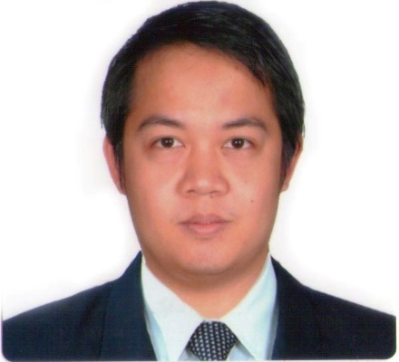
Marvin
CUSTOMER SERVICE CHAMPION
Email: marvin.351420@2freemail.com
Land: C/o 0505891826

//SKILLS
- Advance Skill in Microsoft Office– Word, PowerPoint, Publisher, Excel
- Self-trained in Adobe Photoshop
- Good in written and oral English
- FAST LEARNER

//CAREER HIGHLIGHTS & ACHIEVEMENTS

Last position handled: Escalation Case Manager
Industries dealt with: Insurance, Hospitality (Hotel Reservation), and Telecom
- I have more than 9 years of extensive experience in CUSTOMER SERVICE.
- I have dealt with different people from individual services to large scale businesses.
- I always meet if not exceed my metrics– Attendance, Quality, Case Handling Time.
- I was promoted as a Quality Analyst in one of my previous employment.

//EXPERIENCE
Company Name: Sykes Asia Inc. Date: Jan 2014—Mar 01, 2017
Position: Haste and Escalation Case Manager Industry: Financial/ Insurance

Company Name: Serco Date: Aug 2010—Sept 2013
Position: Senior Hotel Reservation Specialist Industry: Hospitality

Company Name: Teleperformance Date: May 2009—Aug 2010
Position: Customer Service Representative Industry: Telecom

Company Name: TeleTech Date: Oct 2007—Mar 2009
Position: Customer Service Representative Industry: Telecom

Company Name: Gobal 9, Inc. Date: Apr 2007—Oct 2007
Position: Quality Assurance Analyst Industry: Financial/ Mortgage

//EDUCATION
Universidad de Manila - Mejan, Gardens, Manila
Degree: Bachelor of Arts in Mass Communication
Graduated: Mar 2007

