Radhika
Radhika.351431@2freemail.com

Assignments:-
Internal Audit – RTR, PTP, OTC, Master Data, Financial Management, Reporting & Balance
Sheet Reconciliation

Experienced, Resourceful and effective Financial Analyst with proven proficiency in Internal
Audit – RTR, PTP, OTC, Master Data Financial Management Reporting & Reconciliation

Profile Summary
Accounting Professional with over 3 years of experience, in the field of Internal Audit – RTR, PTP, OTC, Master Data, Financial Management, Reporting & Balance Sheet Reconciliation, Inventory Audit, Business Process Improvement.

I consider myself a responsible, creative, with initiative and punctuality, I accept the challenges and goals that your organization could assign me with pleasure. And with good handle of the interpersonal relationships,
ability to work in teams, ability to work under high pressure, so as to solve problems efficiently and achieve the goals set by the company and my work group. Ease and willingness to learn, good interpersonal relationship |  | Quick Learner  Restorative  Individualization
skills, responsible, creative, organized, ability to make tough jobs quickly, |  | Communication/Presentation
interest in professional development, extensive experience in the field of |  | Arranger
finance, leadership and decision making |  | Focus
 |  | Activator
 |  | Positivity
IT Skills |  | Adaptability
 |  | Maximizer

Top X Strengths

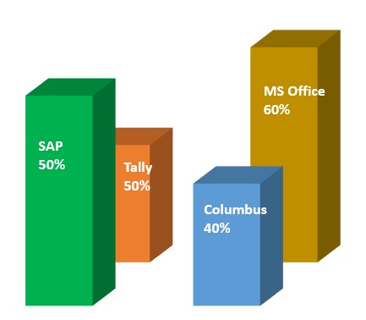

Education

2013 MBA – Finance, HR ; Anna University of Technology, Chennai – 44th Rank Holder

2011 BBA – Mahatma Gandhi University, Kottayam, Kerala

Personal Details
Date of Birth: 29th January 1991

Languages Known:-
Malayalam, English, Hindi, Tamil, Kannada

Nationality : Indian
Career Timeline

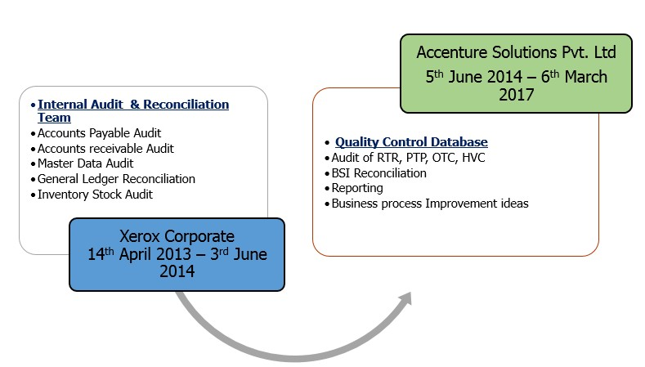Roles & Responsibilities

5th June to March ‘17
Accenture Solutions Pvt. Ltd

Finance Analyst (RTR) – Quality Assurance (Quality Control) From

June’14 to March ‘17

Accenture Financial Services, Bangalore, Karnataka, India.

At Quality Control team:
Quality check of process done by different team under PTP, RTR, OTC & HVC, Master Data.
Creation, Modification, Deletion & Review of Quality Control
Database
Updation of QCD website with the Control Lapse, if any
Seeking approvals from managers for publishing QCDs
Reporting the activities
Taking presentations (awareness programme) to different teams regarding QCD
OPEX activities.
Reconciliation/Balance Sheet Reconciliation of items on monthly basis and its reporting.
Suggesting Controls and providing ideas to Operations Team to improve productivity, reduce time & cost.
Providing awareness sessions of process to Operations Team.
Business Process Improvement ideas.
Associate – Internal Control (Audit) Apr’13 – June ’14

14th April 2013 – 3rd June
2014 – Xerox Corporate
ACS India Private Ltd, a Xerox Company, Cochin, Kerala, India.

At Internal Control team:
Audit of Accounts payable (Invoicing, Rebilling), Accounts receivable (Invoicing, Rebilling, Ex-employee, Reconciliation auditing), Master data (Customer, Vendor).
Creation of audit sample as per the payment proposal files and audit criteria and reporting activities
Providing the confirmation for payment to the payment department.
Auditing and providing confirmation for accounts receivable on daily basis.
Review and updation of manuals on the base of which auditing is done.
Consolidation of error files and preparation of summary report.
Reconciliation of AR Ledger via Columbus tool
Inventory Audit.

Achievements

Won third price in Regional Elocution Competition conducted by PPG College Coimbatore with Mercantile Bank Tamilnadu in 2012
Awarded Jawsmith winner for excellent business presentation from

Accenture in 2014.

Awarded Good Samaritan Award for good performance in 2015 &

2016.

Awarded monetary reward points by the Team Supervisor & Global Delivery Lead for better performance, People Engagement & Collaboration.
Awarded A3 score for Employee Engagement in 2014.

Submitted ideas for process improvement & best practice.

Won Accenture Bangalore Inter Deal Dance Competition in 2015.

Awarded Accenture Global All Hands Award in 2015.

Winner of Throw ball in Accenture Sports Meet, 2016.

