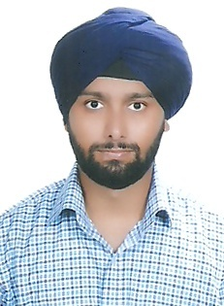
RESUME
Shamsher
Shamsher.351497@2freemail.com

CAREER OBJECTIVE:

To pursue a career in an organization which provides opportunities for professional and personal growth.
Enabling one to learn & grow within the organization and being instrumental in providing promotion along the way.

EDUCATION

Passed High School in (Commerce Stream) C.B.S.E in 2003.

Experience:

Worked as a (Research Associate) in Market Research Organization [EXEVO (India) LTD] From 16th, july,2008 – 14th, January 2009.(6 months)

Worked as a L1 Tech Support for (AOL Broadband U.K) in [WIPRO LTD.] From 11th Sep 2009 - 23rd july2010.(10 months)

Pursued Graduation, Self-Employed -- writing blog’s on- (blogger.com & Wordpress.com) 2010-2016.

SKILL

Team player & quick learner. Active participation in team activities
Exhibiting intensity to win.
Strong interpersonal skills. Well modulated voice with rich vocabulary base, used with verve and vivacity.
Well versed with Ms-office, Email & Internet.

Extra-Curricular
Reading Novels, Magazine (Outlook, National Geographic & India Today). Represented school in football.

Preferred Country: U.A.E

PERSONAL DETAILS:

- Date of Birth/Age : 25-05-1985/31yrs
- Sex : Male
- Languages Known : English, Hindi &Punjabi
- Nationality : Indian
- Valid Passport : Yes
- Marital Status : Unmarried

DECLARATION

- I hereby declare that the above information is true and according to best of my knowledge.

