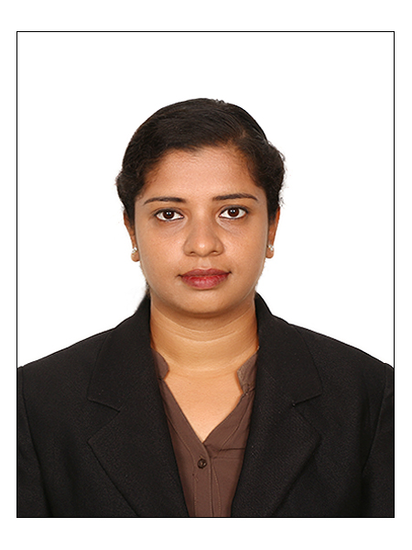
SURYA
SURYA.351560@2freemail.com

PROFESSIONAL SYNOPSIS

In pursuit of challenging assignments in the field of Customer Support, In-housestock management,Administration, Logistics,Staff attendance,Purchasemanagement with an organization of high repute.

PROFESSIONAL EXPERIENCE
5 Years Customer Support Experience details: Professional 3 years’ experience in Motilal Oswal Securities Ltd and 2 years in NIIT and Accopedia and professionally experienced in handling Admin, Operations, Courier, Cargo management and Banking operations management.

- ADMINISTRATION AND MANAGEMENT IN MOTILAL OSWAL SECURITIES LTD – From April 2015 to Current

- Responsibilities & Achievements:

- Dealing with all depository activities and transaction of clients related to share market investments, coordinating, and enforcing program.

- Implementing High standards of new workflow and process according to the companies challenging decision in each division in Back office operations.
- Preparing comparison reports in Equity market, monitoring security procedures and protocols.
- Solving all customer related queries regarding Securities market and maintaining reports of Portfolio Management Services.

- Maintains physical condition of office by planning and implementing new design layouts; inspecting equipment, issuing work orders for repair and requisitions for replacement.Excellent space management skills.
- Operation Handling in New account opening and Modifications in Demat account and watching over Risk Management Services

- Maintaining Surveillance reports and Efficient Event Management
- Maintaining Staff attendance, Salary Calculations, New Appointments, Leave balance calculations and other HR related works
- Dealing with AMCs regarding Mutual Fund investments

- AREAS OF STRENGTH
- Shipping and Receiving
- Internal & External audit
- Process Improvement, Report presentation, Effective cost management,
- Recruiting& Developing staff skills.
- Training, Supervising,Strong Administration skills.
- Project Management

PROFILE SUMMARY& CORE COMPETENCIES

- Over 5 years of experience in Customer Support,Logistics Operations, Purchase,Supply Chain Management, P & L Management for clients as well as the organization, Depositary operations, Cargo / Courier service management,and Process Management .
- DP related documentation / finance related works.
- Adroit in planning and maintaining an efficient Depositary operations & evaluating the work performance.
- Leading the Logistics department and heading overall responsibilities DP Operations and Reporting to Business Head as well as CFO&CEO.
- Office management including purchase of stocks, issue of IPO and other purchase related works.
- Managing effective costing system resulting in cost reduction, business process and procedures
- Adept in supervising logistics operations & ensuring timely execution while adhering to transit guidelines
- Monitoring availability of stock, making appropriate arrangements to ensure the timely solving of customer queries
- Expertise in back office operations involving coordinating with AMCs and Vendors

ORGANISATIONAL EXPERIENCE

- COORDINATOR in ACCOPEDIA SCHOOL OF ACCOUNTING AND FINANCE,COIMBATORE
- Position : Coordinator
Duration : February 2014 – September 2014
- Role :Coordination in arranging classes to graduates and placing them in leading Concerns

- Responsibilities& Achievements:

- Will Handle all Admin Expenses and Allocate batches for students
- Supervising in the Website and Logo creation of the Company
- Ensure students to get good guidance from faculties
- Scheduling the classes to the students by checking the availability of Faculties
- Ensure the convenience of students in premises
- Issuing ID cards and study materials to students
- Collecting fee from students term wise
- Maintain staff as well as student attendance
- BACK OFFICE HEAD in MOTILAL OSWAL SECURITIES LTD,COIMBATORE
Location : India
Employer : MotilalOswal Securities Ltd, India.
Position : Back Office Head
Duration : February 2012 – October 2012
Role : Heading Inward & OutwardClearing, Portfolio Management Service, DP Operations

- Role & Responsibilities:
- Handling inward & outward clearing operations management, DP operations management

- Dealing with all depository activities and transaction of clients related to share market investments, coordinating, and enforcing program.

- Handling DP operations management (Inward & Outward)& Documentation process, Demat and Remat operations, Demat account opening & documentation.

- Solving all customer related queries regarding Securities market and maintaining reports of Portfolio Management Services.

- COUNSELLOR IN NIIT,COIMBATORE
Location : Ram Nagar, Coimbatore, Tamil Nadu, India.
Employer : NIIT
Position : Counsellor
Duration : May 2011
- Role & Responsibilities:
- Allocate batches for students
- Ensure students to get good guidance from faculties
- Ensure the convenience of students in premises
- Conducting Grooming sessions for students required for placements
- Collecting fee from students term wise
- Ensure the batch filling and Faculty timings

AWARDS AND LAURELS
- Good Performance Appraisal rating at all the levels.
- Received Proficiency certificate in four subjects in Collage including French.
- During my tenure as project chairman our Rotaract club of ADU bagged "Best Project Award in Dist 3201
- Won Best Performer Certificate in NSS.
- Won Best Coordinator award in NIIT

EDUCATIONAL PROFILE

- 2006 – 2009 : Graduate in B.Sc., Life Sciences in Avinashilingam, Deemed University,
Coimbatore. (With 83% in aggregate)
- 2004 – 2006 : Higher Secondary Education at P.S.G.R.Krishnammal Girls
Higher Secondary School, Coimbatore. (With 70% in aggregate)
- 2004 : Secondary Education at St’Marys Girls Higher Secondary School,
Coimbatore. (With 94% in aggregate)

EXTRACURRICULAR ACTIVITIES
- Actively participated in Social Works in NCC, NSS at School and College Level
- Member of College Rotaract and active conducted projects

TECHNICAL SKILL SET
- Languages :Visual Basic, C++, DBMS, HTML.
- Packages :MS-Office, Tally
- Platforms Worked :MS-DOS and Windows 98 – 2007 & XP

PERSONAL PROFILE
- Date of Birth :25th July, 1989
- Linguistic Abilities :English, French, Tamil,Hindi &Malayalam.
- Nationality :Indian
- Marital Status :Married
- No. of Dependants :3

DECLARATION

I hereby declare that the foregoing information are true and correct to the best of my knowledge and belief and that I have not concealed any information, which might affect my suitability for this job and I am confident that I can serve to the best of my effort.

Note: Reference will be provided based upon the requirement

