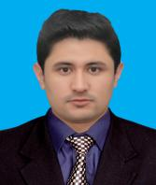

E-mail: shabbier.351568@2freemail.com
Shabbir
Strengths:
Communication Skill
Hard working
Responsible
Leadership
Time Management

Career Objectives:
I am seeking employment with a company where I can use my talents and skills to expand the company.
Professional Education:

2013 2017 BE(EE) Bachelor Of Engineering In Electrical Electronics.
Hmadard University Islamabad
CPGA=3.04 - ( 73% Average)

2008 2011 DAE(3 year Diploma in Electrical Technology)
Jinnah Poly Technic Institute Karachi
Marks (2596/3500) 1st Div - (74%)

2005 2007 Metric(science) Govt Model High School ,Nasirabad Hunza, Gilgit
Marks(560/850) 1st Div-(65%)

Project:

- Electronic Power Trainer

Computer skills:

1.Ms Office 2.Auto-CAD 3.Matlab 4.Proteus- Professional

Personal Data:

Date Of Birth: 20-07-1990
Martial Status: Single
Interest: Books,Newspaper and Net Browsing

Reference:

Reference will be furnished when required.

