CURRICULUM VITAE
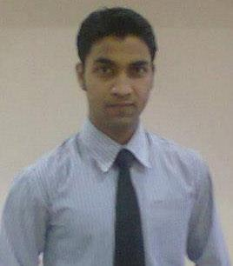

Kaizar
E-mail: kaizar.351589@2freemail.com

CPC Insurance Medical Coder with 2.7 Years Experience

Career Objective:
“Seeking a healthy & challenging environment where in my academic knowledge & experience can be shared and enriched. I can prove my skills with development in Standard of Living.”

Professional work experience:
- Currently working as Quality Control Analyst with Omega Healthcare Pvt Ltd, Bangalore.

- Having overall 2.7 years of work experience in ICD(9 &10), CPT ( E&M and Surgery) coding with Omega Healthcare Pvt. Ltd and Inpatient coding with United Health Group(XL Healthcare).
3. Having work experience in the most valuable project. OPTUM, Highmark, Perimeter, T-system.
4. Experienced as a Trainer and Support for Inpatient, ED and Surgery coding along with ICD-9 and ICD-10 proficiency.
5. Experienced in Client handling and project management.

Strengths:

- Results driven & aggressive with high personal and career goals.

- Excellent interpersonal skills with people from all levels of corporate management.

- Excellent presentation and public speaking skills.

- Possess lots of initiative and self-motivation with a highly objective and result-driven mindset.

Current Company: Omega Healthcare Pvt. Ltd.

Current CTC: 5.3Lacs INR/Annum

Certification: CPC from AAPC

Notice Period: 2 Months.

Educational Qualification:

Exam | Institute | University/Board | Year of Study
X | Jawahar Navodaya Vidyalaya | CBSE | 2006(May)
XII | Jawahar Navodaya Vidyalaya | CBSE | 2008(May)
B.Pharmacy | T.John College of Pharmacy | RGUHS | 2012(Dec)

Skills:

Technical | Excellent in MS office.
Interpersonal | Communication & interpersonal skills  Ability to adjust in any environment  Perform multiple tasks

Personal Profile :

Extracurricular activities: Singer, Public Speaker.
Participated in various state level pharmacy seminars.

Sports: Cricket

Interest & Hobbies: Singing, Learning about coding and Filmy gossip.

Languages Known: English, Hindi, Bengali, and Arabic (read, write, speak)

Sex | : | Male
Nationality | : | Indian
Marital Status : |  | Single
Religion | : | Islam
Date of Birth | : | 11/03/1990

Declaration:

I solemnly declare that to best of my knowledge and belief, the information given in

the resume are correct and complete and that the particulars shown therein are truly stated.

Place: Chennai

Yours Faithfully

(KAIZAR)

