CURRICULUM VITAE
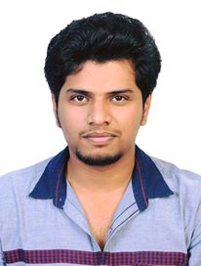
SIVA
Siva.351592@2freemail.com

CAREER OBJECTIVE

To be part of a reputed establishment and contribute my best for its progress, with continuous learning and acquisition of new skills.

PROFESSIONAL DEVELOPMENT

- B.Tech ECE
- RHCE,RHCSA,CCNA,CCNP
- CCNA CERTIFIED FROM MAY 2ND 2016

PLATFORMS AND OPERATING SYSTEMS

- Windows OS: Windows –XP,7,8,10
- Languages: Basics of C, C++
- Computer Skills: MS Office (Word, Excel, PowerPoint)

EDUCATIONAL PROFILE

➢ B.Tech Electronics and Communication (2011-2015)
CGPA: 6.06
University: Kerala University
College: Sree Budha college of Engineering, Alappuzha,kerala

PROJECT

MAIN PROJECT:
Title: AUTOMATIC RATION DISTRIBUTION SYSTEM USING GSM & RFID
- Having an online web-based system
- Risk of data loss can be minimized effectively
- Can be extended to store user’s finger print for improved security
Institution: Sree Buddha college of Engineering, Alappuzha, kerala

MINI PROJECT:
Title: HEARING AID
Institution: Sree Buddha college of Engineering, Alappuzha,kerala

SKILLS AND STRENGTHS

- Quick learner with grasping ability
- Good team player

DECLARATION

I here by declare the information furnished above is true to the best of my knowledge and belief.

