CURRICULUM VITAE

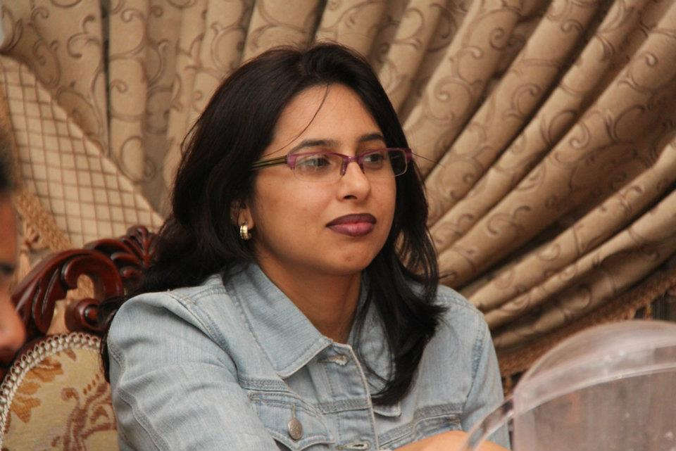
Ms. RAVINDER
RAVINDER.351619@2freemail.com

CAREER OBJECTIVE
Seeking opportunities for professional growth, challenging assignments, increasing responsibilities etc. as a Teacher/Lecturer in an organization where individual merits, dedication, innovative approach, team spirit is recognized and rewarded.

EDUCATIONAL QUALIFICATIONS
- Pursuing Diploma in Teaching & Training with Specialization in TESOL/TEFL Program.
- Completed TESOL approved ELT advantage online course – An Introduction to Teaching English to Young Learners (2009)
- Obtained Activprimary Foundation Skills Certificate from Promethean Learning.
- M. Sc ( Applied Genetics/Biotech -Science) from Acharya Institute of Sciences, Bangalore University ( Karnataka ) with aggregate of 71% ( 2004 )
Holding 3rd Rank In Genetics Dept.in Bangalore Uni.
- B. Ed from Ramgarhia College of EducationPhagwara (GNDU Amritsar ) with aggregate of 65% (2002 )
- B. Sc ( Chemistry, Botany, Zoology) from Lyallpur Khalsa College Jalandhar (GNDU Amritsar ) with aggregate of 60% ( 2001 )
- 12th from Guru Amar Dass Public School CBSE with 74.3% (1998)
- 10th from Seventh Day Adventist High School ICSE with 63.4% (1996)

COMPUTER SKILLS

Certified with International Computer Driving Licence( ICDL ) &
IELTS :General 7 Academic – 7

PERSONAL INFORMATION

Date of Birth : 16 Sept.1979
Nationality : Indian
Marital Status : Married
Languages Known : English , Hindi , Punjabi

Date of Expiry : 1 Nov 2021
Visa : Husband Sponsorship ( Over in 2018 Aug )

WORK EXPERIENCE
- Presently, working as LSA with Gems Wellington International School
( National Curriculum of England )
Key responsibilities:
- providing support to children with mathematics, reading and writing on an individual, class or small group basis
- helping to develop programmes of learning activities and adapting appropriate materials
- motivating and encouraging pupils
- assisting with marking and correcting work
- attending meetings and reviews
- helping with school events, trips and activities
2 Worked as a Primary Teacher with Amled School from April 1st 2015 - June 30th 2015 (CBSE)
- Worked as a Primary Teacher with JSS International School, Dubai ( ICSE ) from April 1st 2010 to May 2013.
- Worked as a Primary Teacher with JSS Private School, Dubai ( CBSE) from May 2013 to 31st March 2015( Internal Shifting)

JOB RESPONSIBILITIES
- teaching all areas of the primary curriculum;
- taking responsibility for the progress of a class of primary-age pupils;
- organising the classroom and learning resources and creating displays to encourage a positive learning environment;
- planning, preparing and presenting lessons that cater for the needs of the whole ability range within their class;
- motivating pupils with enthusiastic, imaginative presentation;
- preparing and marking work to facilitate positive pupil development;
- meeting requirements for the assessment and recording of pupils' development;
- providing feedback to parents and carers on a pupil's progress at parents' evenings
- coordinating activities and resources within a specific area of the curriculum, and supporting colleagues in the delivery of this specialist area;
- working with others to plan and coordinate work;
- keeping up to date with changes and developments in the structure of the curriculum;
- organising and taking part in school events, outings
- Worked as a Teacher in The Apple International School ( O level ), British Curriculum , Dubai UAE from Sept.2007 to March 2010

JOB RESPONSIBILITIES
- motivating and stimulating the children's learning abilities, often encouraging learning through experience;
- providing pastoral care and support to children and providing them with a secure environment to learn;
- devising and producing visual aids and teaching resources;
- organising learning materials and resources and making imaginative use of resources;
- assisting with the development of children's personal/social and language abilities;
- supporting the development of children's basic skills, including physical coordination, speech and communication;
- encouraging children's mathematical and creative development through stories, songs, games, drawing and imaginative play;
- developing children's curiosity and knowledge;
- working with others, including teaching assistants and/or nursery nurses as well as volunteer helpers, to plan and coordinate work both indoors and outdoors;
- observing, assessing and recording each child's progress;
6 Worked as Primary Teacher in Leaders Private School, Sharjah UAE
(2006-2007)
Teaching the basics of numeracy, literacy, music, art and literature to students at primary school and promote students' social, emotional, intellectual and physical development.
- plan and structure learning in both indoor and outdoor environments using a variety of materials and equipment to facilitate students' development
- provides a variety of experiences and activities to develop motor skills, cooperative social skills, confidence and understanding
- observes students to evaluate their progress and to detect signs of ill health, emotional disturbance or other disabilities
- discusses students' progress with parents
- attends parent interviews, staff and committee meetings
- participates in community and family support programs as appropriate
7 Worked as a Lecturer in the Dept of Genetics / Biotech, The Oxford College of Science Bangalore from 01 Sept.2004 to 31 Aug 2006 having Exp. of 2 years at PG & UG level.

JOB RESPONSIBILITIES
- To teach at undergraduate and graduate level in areas allocated by the Head of Department and reviewed from time to time by the Head of Department.
- To contribute to the development, planning and implementation of a high quality curriculum.
- To assist in the development of learning materials, preparing schemes of work and maintaining records to monitor student progress, achievement and attendance.
- To participate in departmental and faculty seminars aimed at sharing research outcomes and building interdisciplinary collaboration within and outside the department.
- To participate in the development, administration and marking of exams and other assessments.
- To provide pastoral care and support to students.

