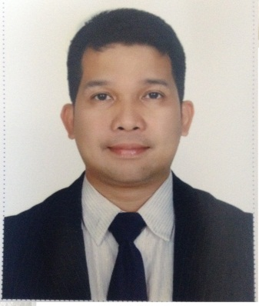
E-mail : emiliano.351692@2freemail.com AL QUSAIS DUBAI, UAE
EMILIANO
Objective | To apply in an extensive position in a challenging, creative and stable environment that would utilize my banking knowledge and experience
Work experience | January 2016 -- Present Dunia Finance LLC Dubai UAE  Relationship Officer- Personal loan, Credit Cards, Auto Loan  - Analyze applicant’s financial status, credit, and property evaluations to determine feasibility of granting loans  - Meet with applicants to obtain information for loan applications and to answer questions about the process  - Explain to customers the different types of loans and credit options that are available, as well as the terms of those services.  - Obtain and compile copies of loan applicants' credit histories, corporate financial statements, and other financial information  June 2010 – December 2015 Sterling Bank of Asia Ortigas Ctr. Pasig City  Collections Associates- Recovery / Auto loan/ Real estate loan  - Responsible in managing External Service Providers/Outsourced Agencies  - Responsible for collating documents needed in pursuing collection through judicial means  - Responsible in ensuring that External Service Providers achieve their monthly targets.  - Monitor/Identify the real and Technical Past due.  - Prepares and served the notices and follow the follow up the payments.  - Reconcile payment records with the client.  - Safe keep and ensure the proper endorsement of the NPL accounts and voluntary surrender of the unit/property.  - Ensure that final actions are initiated to collect and recover from past due accounts with the objective of reducing past due REL/Auto loan as well as reducing NPL ratios.  October 2006 – June 2010 Chinatrust Bank Fort Bonifacio Taguig City  Collections Associates Personal loan and Credit cards  - Reduce and maintain a low delinquency rate of the Portfolio of Personal loans – Public (Preventive and Mid-range unit [Current up to 61 to 90 days past due])  - Achievement of collection targets – Delinquency/Flow rates, NPL and Loss Provisions.  - Prepare collection notices and monitor the flow rates of my handle portfolio  September 2005 – SepJuly 2005 - September 2006 Avida Land Corp. Makati City Makati City  Collection Assistant  - Handling Current/ Past due Accounts  - Monitor and update monthly collection of checks  - Receives and replenish checks from clients  - Coordinates with site offices and other departments regarding status of each account.  - Gives remedial collection measures to clients  - Prepare Monthly Collection report.  March – July 2005 Laguna Properties Holdings, Inc. Makati City  Bank Financing Assistant  - Monitors loan releases, documentary deficiencies and prepare letters for migration of buyer and prepare for computation sheet.  - Maintain good working relationship with bank officers and personnel.  - Prepare the presentation materials for Bank Financing for the sellers.  July 2004-March 2005 Laguna Properties Holdings, Inc. Makati City  Receivables Assistant - Consultant  - Collates & assembles all documents required to sale of receivables.  - Due diligence on loan folders of all interest-bearing in-house accounts.  - Monitors and maintain collection efficiency and reconciles status reports against sales report of accounting using SAP.  - Collection of PDC’s / Cheque replenishment if accounts are for sale.  - Coordinate with buyers, Accounting, Sales Operations regarding various concerns.
Special Skills
Knowledgeable in Computer operating system and SAP. Proficient in Windows such as Microsoft Office, Word, Excel, PowerPoint, etc.

Education | 1993-1999 Polytechnic Univ. of the Philippines Sta.Mesa Manila  Bachelor of Science in Mathematics minor in Computer Appl’n.  1989-1993 Alabat Island National High School Alabat, Quezon  High School Diploma  - Student of the Year-1993, Model Student – 1992 &1993, Top 10 Honor Student

