OROKA
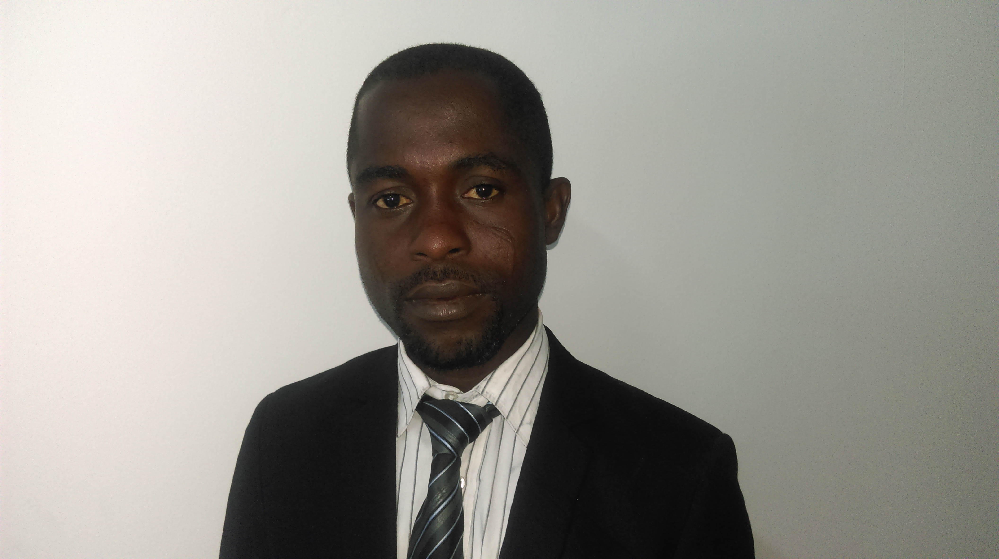
Email Id: oroka.351698@2freemail.com
Date of birth 16th April, 1982
Sex Male
State of Origin Delta
Nationality Nigerian
Marital Status Married
Religion Christianity
Career Objective
My main objective, TO work towards achieving the great success in my career through hard work , consistency and the ability to work with others to achieve organizational goals.
Working Experiences

Company: fahem abdulla safety and security equipment installation l.l.c dubai.

Position : pipe fitter and maintenance

Responsibility: to install fire pump machine and maintenance, with all type of valve that involve mechanical system, deluge system installation , ability to interpret machince drawing to determine specific installation point.

Precommission: all type of mechanical valve e.g check valve ,pressure control valve, gate valve fire alarm valve.

PROJECT: Escravos Gas to Liquid (EGTL)
CLIENT: Chevron Nig Limited/Bruzotus Nigeria Limited (May 2013-feb 2015)
POSITION: welding and fabrication
RESPONSIBILITY: mechanical operation, fabrication, welding equipment, quality, drilling metal stock or component, set up and adjust metal working machines and equipment and maintent all mechanical machines, connects cables from welding unit to obtain voltage slope specified by engineer and ability to interprets machince drawings to determine specific welding requirement , gas line pipe welding
PRECOMMISSION: Of all welding and fabrication equipment e.g calibration machines ,
welding machine, cutting machines, drilling machines etc

PRESERVATION: Involves preservation of all welding and fabrication equipment, mechanical, electrical ‘equipment, purge of skid with nitrogen.
COMPANY: SOMENI NIGERIA LIMITED WARRI ( 2010- 2013)
position: assistance mechanical engineer
DUTIES AND RESPONSIBILITIES
Responding immediately to equipment breakdowns.
- Repairs of all plumbing works and carpentry works.
- Maintains a clean and safe work environment.
- Reads blueprints, works from specification and follows instruction both written and oral
- Handle personal tools for job including up- to- date documented personal tool lists.
- Comply with company safety guidelines and procedures
- Performs related duties as assigned.
- Performs routines and preventive maintenance on specialty equipment
School Attended With Dates
- UNIVERSITY OF BENIN, BENIN CITY, NIGERIA 2005
- ODORUBU COLLEGE, ODORUBU, DELTA STATE 1997
- OTOVWODO PPRIMARY SCHOOL, OTOVWODO, UGHELLI 1989
Qualification Obtained With Dates
- B.ENG (HONS) MECHANICAL ENGINEERING. (attested in uae) 2010
- SENIOR SCHOOL CERTIFICATE EXAMINATION (SSCE) 2002
- PRIMARY SCHOOL LEAVING CERTIFICATE 1994
Other Qualifications with Dates
- PETROLEUM TRAINING INSTITUTE (PTI) NIGERIA 2014
CERTIFICATE OF INSTRUMENTATION (PNEUMATIC) AND CONTROL.
- EDDY- POLO LABOUR FABRICATION COMPANY (EEPLFC) 2013
CERTIFICATE OF GENERAL CONSTRUCTION WELDING ENGINEERING/
DESIGN
- NATIONAL YOUTH SERVICE CORP (NYSC) 2012
CERTIFICATE OF NATIONAL SERVICES
Personal Qualities
- Effective Communication and problem solving skills
- Ability to work under pressure tight schedule
- Effective use of initiative , integrity and honesty
- Good Interpersonal relation with ability to work effectively in a team
Training and Skills
- Introduction to automatic control system
- Pressure measurement and control
- Pressure regulator,,, force balance devices
- level measurement and control
- Health safety and Environment (HSE).
- Microsoft office, maintenance job routine, Assembling and services troubleshooting and repair installation, AutoCAD
- Welding and fabrication.
- Flow measurement and control.
- Pneumatic valve final control element (aquator ) maintenance.
Hobbies
Football, Meeting People, Scrabble and Reading

