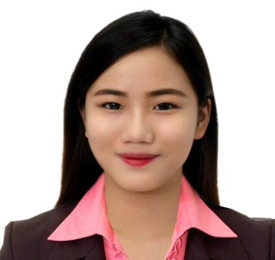
ANSHERINA
Email Address: ansherina.351723@2freemail.com

OBJECTIVE:

Seeking a Company where I can use my experience and knowledge to help the company to meet their goals. To enhance my interpersonal skills and goal oriented personality that will contribute to its growth and success.

SKILLS AND ABILITIES:

- Positive Attitude and hardworking;
- Good in Time Management
- Multi-task oriented
- Computer literate
- Can Speak English and Filipino
- Basic Knowledge about using Amadeus and Abacus/Sabre system
- Knowledge about making Tour packages and visa processing
- Knowledgeable about Ticketing, Reservations and booking of hotel and flights.

WORK EXPERIENCE:

October 26, 2015 – February 11, 2017: Travel Consultant / Ticketing and
Reservation Agent

VIA PHILIPPINES - Flightraja Travels Pvt. Ltd
Unit 405-406-407, 4 F Five E-com Center Building
Block. 18 Pacific Drive, Mall of Asia Complex 1300
Pasay City, Philippines

- Assisted agents inquiries from different travel agencies regarding their bookings on how to book a flight using our portal, advised ticket restrictions from the airline, manually issued/reserved their flights. Added baggage allowance, responded on their emails and answered phone calls, cancel and refund their tickets. Rebooked the flights.

October 5, 2014 – October 10,2015: Reservations / Ticketing Agent in Domestic
And International Department

Bridges Travel and Tours
Unit 801 Liberty Center Bldg.104 H.V Dela Costa
Salcedo Village Makati City, Philippines

      - Booked flights using Amadeus and Abacus system
      - Issued E-Tickets
      - Making / customized a Tour packages of a different
Destinations in Asia and some part of Europe
      - Assisted client inquiries through email and phone calls
      - Handled / processed visa application and documents

ACHIEVEMENT:

Awards:
- Top Performing Agent, November 2016
- Top Performing Agent, October 2016
- Top Performing Agent, May 2016
- Top Performing Agent, April 2016
- Top Performing Agent, February 2016
- Top Performing Agent, November 2015

SEMINARS/TRAININGS:

October 18-21,2016 : Sabre Basic Reservation Training
105 H.V Dela Costa Street, Salcedo Village. Makati, Metro
Manila. Trafalgar Plaza

May 2015 : Amadeus Basic Course Training
LKG Tower, 6801 Ayala Ave, Makati, 1226 Metro Manila

January 2015 : Advance Passenger Service Agent Course, Sky Aviation Learning Center (APSAC)
(TESDA; PATTS College of Aeronautics, Paranaque City)

July 2014 : Basic Passenger Service Agent Course
Sky Aviation Learning Center (BPSAC)
(TESDA; PATTS College of Aeronautics, Paranaque City)

July 2014 : Manila Tourism Summit 2014
(Sofitel Hotel, CCP Complex Roxas Boulevard, Pasay City)

EDUCATIONAL BACKGROUND:

TERTIARY Bachelor of Science in Tourism Management
2011-2015 PATTS College of Aeronautics
Lombos Ave., San Isidro, Parañaque City

PERSONAL DATA:

Gender : Female
Age : 22 yrs. old
Height : 5’4
Birthday : December 28, 1994
Civil Status : Single
Nationality : Filipino

