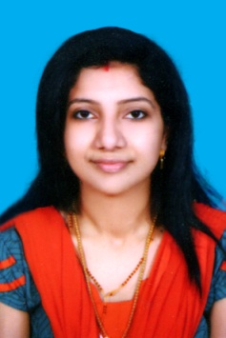
SHINI

Email: shini.351731@2freemail.com
AAPC , CPC-A

OBJECTIVE: Seeking a Medical Coder position in a Hospital, Clinic / or an Insurance Company where I can utilize my extensive computer and medical apparel knowledge and strong organizational abilities.

SKILLS AND STRENG
- Knowledgeable with regard to Medical Coding guidelines and coding techniques (ICD-10 CM, CPT-4, and HCPCS).
- Expertise in all types of coding (Outpatient diagnosis and Procedure coding) and other clinical vocabularies.
- Strong knowledge of Anatomy & Physiology, Advanced Medical Terminology, and Pharmacology.
- Efficient in Microsoft Office Software, including Word, Excel, and PowerPoint.
- Able to type 50+ words per minute.
- Possess good interpersonal, communicational, and organizational skills with demonstrated abilities in team management and client relationship management.
- Ability to manage multiple tasks in a pressured environment.
- Effective communication and interpersonal skills.
- Dedication and drive as a hard-working individual.

ACADEMIC CREDENTIALS
Qualification | Year of Completion
Certified professional coder (CPC-A)  AAPC, SALT LAKE CITY,US | December-2016
Diploma in Nursing  Mahrashtra Nursing Council, India | 2005-2009
H.S.S  From Board Of Higher Secondary Examination, Kerala | March 2004
S.S.L.C  From Government Of Kerala | March 2002

Professional Work History

Worked as Registered Nurse in India and Kuwait

PERSONAL DETAILS

- Date of Birth: 13/06/1986
- Nationality: Indian
- Religion: Christian
- Marital Status: Married
- Languages Known : English, Hindi,Malayalam

DECLARATION

I, HEREBY DECLARE THAT ALL THE INFORMATION GIVEN ABOVE ARE ACCURATE & TRUE TO THE BEST OF MY KNOWLEDGE.
I WILL DO MY BEST & PROVE MYSELF WITH MY HARD WORK & SINCERE EFFORTS IF A CHANCE IS OFFERED TO WORK IN YOUR ESTEEMED INSTITUTION.

Place: DUBAI SHINI

