CURRICULUM VITAE
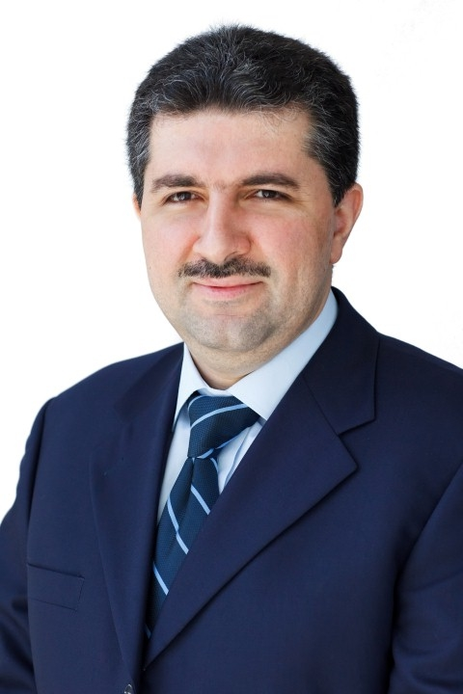

I - Personal Data:
Name : SAAD
SAAD.351744@2freemail.com

II - Education & Qualifications:

- Post Graduate Diploma in Human Resource Planning (2007): University of Cambridge – UK
- Bachelor of Arts , English Literature (1996) : University of Aleppo – Syria

III – Professional Training Courses:

- Strategic Thinking & Planning, by Spearhead Training Institute, Dubai – U.A.E.
- Negotiation Skills, by Napier Associates, London – UK
- Organizational Behavior & Change Management, by Knowledge Horizon, Dubai – U.A.E.
- Protocol Management, by Knowledge Horizon, Dubai – U.A.E.
- Sales Management and Leadership, by Knowledge Horizon, Dubai – U.A.E.
- HR Management Skills, by Spearhead Training Institute, Dubai – U.A.E.
- Effective Leadership Skills, by ExecuTrain, Dubai – U.A.E.
- Internal Quality Auditor Training (ISO 9001: 2000): Conducted by FAHSS – a member of RWTUV, Germany
- Advanced Business Management Training Course : Superior Business Management Techniques by
Mercuri International, Middle East Regional Office, Dubai – U.A.E.
- Computer Training Courses: MS Office Package, Web Page Designing, MCSE 2000

IV – Working Experience:

- Regional HR Manager – MEA, JLL – Dubai, U.A.E., since (01-Jul-2014 till now):
Provide business partnering support and ensuring the smooth running of the HR function within the MEA region (Middle East, Turkey and Africa).

Major Responsibilities include:

- Primary source of advice and support for Line Managers in all aspects of Human Resources, including building and implementing policies, disciplinary & grievance handling, business reorganization, compensation and benefits, market benchmark data and recruitment
- Undertake all mobilization and transitioning project work within the MEA Region
- Coordinate promotions, salary and bonus reviews within the countries responsible for, ensuring alignment within the whole of EMEA Region
- Work closely with Line Managers and HR colleagues to professionally complete Annual Performance Review process, Talent Management & Succession Planning for the MEA Region
- Support and manage the training and development activity across MEA Region
- Supervise and manage the monthly payroll process through the MEA Region
- Provide HR monthly reports to senior management, including headcount, turnover, recruitment, disciplinary and grievances, and severance trackers

- Ensure that the Company is compliant with HR requirements according to H&S, and each Country's required local and legal processes, actions and statutory regulations

- HR Manager – MENA, JLL – Dubai, U.A.E., since (22-Feb-2010 till 30-Jun-2014):
Leading & Managing different core HR related issues, including recruitment, training and development programs, compensation & benefits and supervising daily HR operational issues.

Major Achievements include:

  - Leading JLL-MENA recruitment process, including permanent, temporary and internship employment
  - Negotiating and drafting employment contracts within MENA in compliance with Labor Laws
  - Providing HR consultation on different rules and regulations related to recruitment, contract termination and final settlements for JLL offices globally
  - Support in updating and modifying HR policies, and the implementation of the total reward structure
  - Collaboration with regional and international universities for building pool of talents, and support the introduction and implementation of JLL-MENA Graduation program
  - Support the integration and engagement with social media networks for a wide and diversified pool of talents
  - Planning and organizing internal & external development workshops, and professional training courses
  - Retaining salary grading structure, and professional job titles in harmonization with different business lines
  - Handling the annual Talent Review process, as well as salary & bonus reviews
  - Active participation in JLL-MENA promotional panels
  - Planning & organizing different team building activities

- HR & Administration Manager, JENGAN EST – Dubai, U.A.E. : since (01/09/2004 till 21-Jan-2010):
Managing & Handling all HR & Administration related issues for a group on companies, specialized in the sales & marketing of engineering equipments in U.A.E & Oman.

Major Achievements include:

- Building & retaining a professional database
- Drafting job descriptions for different technical and professional roles
- Drafting HR policies, and salary grading structure
- Implementing performance appraisal system
- Introducing different professional training courses
- Introducing & implementing medical & life insurance systems

- Assistant Manager – HR & Administration, Electro Industries LLC – Dubai, U.A.E: since (27/09/2000 till 01/08/2004):
Supporting and handling different HR & Administration related issues, and requirements for more than (360) employees of different professional levels & cultures, working for a group of companies specialized in manufacturing and installation of road signage boards, and organizing exhibitions.

Major Achievements include:

- Overseas recruitment of different professional calibers
- Building & maintaining a professional database
- Drafting different HR polices
- Implementing ISO quality system

- Sr. HR & Administration Officer, Business Information Center – Dubai, U.A.E.: since (01/03/1997 till 1/09/2000)
Supporting and handling different HR & Administration related issues for more than (200) employees, specialized in providing commercial, promotional and professional services in collaboration with different UAE government Departments, including Department of Economic Development, Dubai Shopping Festival Office and Ministry of Labor.

Major Achievements include:

- Support in the overall recruitment process
- Support in implementing different HR policies & procedures
- Handling daily HR operational issues
- Organizing different team building activities

- HR & Administration Officer, Acad Commercial Institute – Aleppo, Syria: since (10/01/1996 till 10/01/1997)
Supporting different HR & Administration operational issues in a professional training institute, including translation of different documents from English into Arabic & vice versa.

V – Awards:

- Long Service Award – JLL – Dubai – U.A.E.
- Best Staff Member of the year 2005 - JENGAN EST. – Dubai – U.A.E.
- Appreciation Award Certificate for Outstanding Contributions & Achievements in the year 2005 - JENGAN EST. - Dubai – U.A.E.

