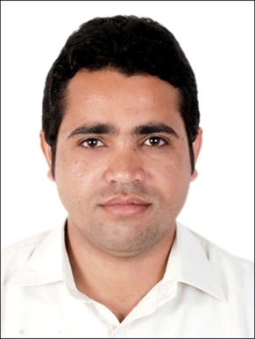
Abdul
Abdul.351749@2freemail.com

CAREER OBJECTIVE

“To obtain position in the esteemed company that enables me to utilize progressive experience and skills in the field of Education, Networking and Management. I want to develop a career by seeking a challenging position in a progressive organization with an aim to contribute positively towards the growth and objectives of the organization to the best of my capabilities, to enhance ethical standards and to develop my professional skills for growth within the organization.”

ACADEMICEDUCATION

Particulars | Year | Institute
Msc (Electronics) | 2015 | University of Karachi.
BSc (Hon’s) in Applied Physics | 2014 | University of Karachi.
Cisco Certified Network Administrator (CCNA) | 2014 | CTTC Affiliated with Cisco Networking academy USA.
IELTS | 2015 | AeO Pakistan.
Intermediate | 2008 | City Grammar college.
Matriculation | 2006 | Govt H/S school kot Samaba.

- Did Internship from Heavy Mechanical Complex Taxila.
- Worked as Math, Eng and Physics teacher in Bab-e-elm academy.
- Worked as Math and Physics (O level’s) teacher in The Educational Center.
- Working as a Math and Physics teacher in Genius Coaching Center.

EXPERIENCE

- Assembly Programming language, C, C++, Programming languages, Data Structure & Algorithms.
- Operating system Windows, XP, Vista, 7, 8 & 10.
- Designing of Mobile jammer & FM Transmitter.
- Networking, Matlab
- Software Installation & Troubleshooting.
- Microsoft Office & Ms project.
- Kiel Micro vision, 8051 Microcontroller & IR based projects.
- Designing of Digital Clock with Five Time Alarm by using Digital ICs.

Professional Skills

Date of Birth: August 10th 1990

Nationality: Pakistani
- Languages: English and Urdu
- Marital status: Single
Willing to travel for official assignments.

- Ability to work in any kind of environment.
- Enjoying learning new methods and technique and putting them into daily practice
- Goal – oriented professional

PERSONAL QUALITIES AND TRAITS

PERSONAL INORMATION

Reading Different Books

Internet surfing

Listen music
- Watching movies
- Playing Cricket
- Attending different seminars and workshops

EXTRA-CURRICULAR ACTIVITIES

