RESUME
SAJNA
SAJNA.351771@2freemail.com 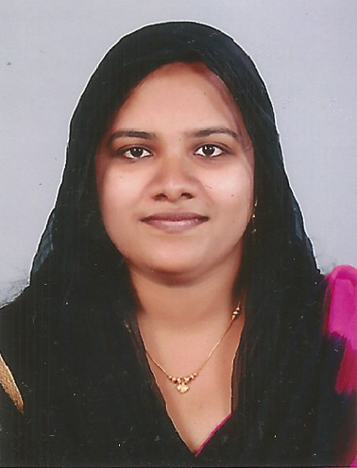

OBJECTIVE:-
- Looking forward to a career where I can share my knowledge and learn with new technologies.
- Looking for a challenging position in a professional and dynamic organization, that promises independent responsibility and linear growth respect.

EDUCATIONAL PROFILE:-
S.S.L.C, Plus Two, B.A English Language & Literature

COMPUTER KNOWLEDGE:-
DOS, Windows and Internet Applications, MS Office

LANGUAGES KNOWN:-
Malayalam, English and Hindi.

HOBBIES:-
Traveling and listening to music

STRENGTHS:-
- Adaptability to changing environment
- Positive thinking.

Personal Skills:-
- Easily adaptable to any environment, able to work under pressure producing the required result.
- Self-motivated, responsible, confident and poised in interactions with individuals at all levels.
- Skilled Organizer and Problem Solver with the ability to consider all options before making a decision.

DETAILS OF WORKING EXPERIENCE:-
- Worked as a Receptionist cum Office Administrator with “EDU – CARE”.
- Worked as a Tele-Caller with "Smart Solutions".
- Worked as an English Tutor for high school and graduate students.
- Worked and trained in Accentia as Medical Transcriptionist.
- Worked as a “Home based Editor/QA”, total of 7.5 years in working as a “Transcriptionist.”
- Worked as a Guest Relation Executive/Hostess with a 5* star hotel.
- Working at KIMS Hospital, Thiruvananthapuram as a Medical Secretary.

PROFESSIONAL EXPERIENCE:-
Receptionist:-
- Welcome visitors, determine nature of business, and direct visitors to suitable employee.
- Answer incoming telephone calls; operate PBX and multi-line telephone system.
- Receive, sort, and route mail.
- Monitor visitor access and issues passes.
- Order, receive, and maintain office supplies.
- Over see maintenance of the reception and waiting area.
- Coordinate customer payments and billing.
AREAS OF EXPERTISE
● Correspondence Handling | ● Phone Etiquette | ● Customer Service
● Reception Maintenance | ● Bill Processing | ● Call Forwarding
● Log Keeping | ● Reception Cleanliness | ● Event Coordination
Telecaller:-
- The role is focused towards generating revenue for the company by marketing / selling products to customers.
- The role also involves maintaining client relationships with the existing clients.
- Responding and Conversion of leads into potential accounts.

Teacher:-

Manages an organized and professional classroom that is conducive to learning and development.

Fosters a cooperative and respectful partnership with families.

Works as part of a cooperative and diverse team of educators and administrators to carry out the vision and mission of school.

Continues intellectual and professional development.

Guest Relation Executive cum Hostess:-
- Greet guests and patrons personally and on the telephone
● Offer appropriate seating arrangements
● Present menus and take orders
● Ensure the quantity of menus is sufficient to cater to the number of guests
● Relay orders to the kitchen and ensure all orders are filled in a timely and accurate fashion
● Set up dining rooms and make reservation arrangements
● Maintain clean and organized tables and work area
● Assist room service when and as needed
● Manage event related work including setting up tables and maintaining both exterior and interior of the restaurant

PERSONAL PROFILE:-
Sex: Female
Nationality: Indian
Religion: Islam
Marital Status: Married
Kid: One
Date of Birth: 29/04/1986
Guardian’s Name: M.H. Farook

DECLARATION:-
I hereby declare that all the information given in the Resume is true to the best of my knowledge and belief.

To,
The H R Manager,

Sub: Application for the post of Receptionist/ Front Office Executive/Guest Relation Executive/Customer Service/Teacher/Medical Transcriptionist/ Medical Secretary

Dear Sir,
I am a graduate in English Literature. I would like to apply for the post of this position in your reputed hospital. I have adequate working knowledge in handling these positions. Now, I am working in a good running firm.
I assure you that, if I am appointed in your firm, I shall try to the best of my knowledge & experience for the betterment of the organization. I would appreciate an opportunity to explain my education and background at a Walk in\ Phone in interview. A self-prepared resume also attach with this.

I look forward to hearing from you.

