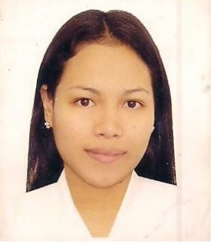

NINA
NINA.351792@2freemail.com

Objective:
To enhance my professional skills, capabilities and knowledge in an organization which recognizes the value of hard work and trusts me with responsibilities and challenges. I am hard working and committed individual with a strong focus on achieving personal goals and succeeding in a professional and challenging environment.
SUMMARY OF QUALIFICATION:
- Strong verbal and personal communication skills.
- Self-motivated, initiative, maintains a high level of energy.
- Tolerant and flexible, adjusts to different situations.
- Organization and prioritization skills.
- Problem analysis, use of judgment and ability to solve problems efficiently.

Licensed Registered Nurse- RN
Professional Regulation Commission Philippines
November 2008
EDUCATIONAL BACKGROUND:

College : Saint Paul University Dumaguete
Dumaguete City, Negros Oriental
(SY: 2004-2008)
Bachelors of Science in Nursing

Secondary : Bais City Science High School
(SY:2000-2002)

Villaflores College
Tanajay City, Negros Oriental
(SY:2002-2004)
Primary : Obogon Elementary School
Tanjay City, Negros Oriental
(SY:1995-2000)
With Honors

Working Experiences:
- September 2014- February 2017
Doha Qatar

Private Duty Nurse

Job description:
*Provided direct nursing care according to care plans.
*Followed standards and protocols of clinical practice in nursing patients at home.
*Administered medications and minor first aid as needed.
*Ensured safety and comfortability of patients at home.
*Followed professional conduct for delivering nursing care to patients.
*Maintained a clean and safe environment around the children; encouraged them to learn and guided them with discipline
*Applies independent emergency measures to counteract adverse development and notifies physician of patient’s condition.
*Directs patient in good health habits.

- August 2011-July 2013
Robinsons Road Hong Kong

Private Duty Nurse

*Safely transported children to and from school, medical appointments and extracurricular activities
*Engaged in after school activities including sport practice and homework
*Regularly traveled with the family to help with activities and childcare
**Provided direct nursing care according to care plans.
*Followed standards and protocols of clinical practice in nursing patients at home.
*Administered medications and minor first aid as needed.
*Ensured safety and comfortability of patients at home.
*Followed professional conduct for delivering nursing care to patients.
*Maintained a clean and safe environment around the children; encouraged them to learn and guided them with discipline
*Applies independent emergency measures to counteract adverse development and notifies physician of patients condition.
*Directs patient in good health habits.

- February 2009-2011
City Health Unit Tanjay City
Birthing Center
Negros oriental Philippines

Staff Nurse
Job Description
*Providing support for the mother during labor
*Administering medications and performing diagnostic tests
*Consulting with physicians and other members of the care team
*Assisting with inducing labor
*Identifying and assisting with complications
*Assisting with various procedures
*Monitoring and performing tests on newborns
*Providing education and support to mothers and families after delivery

I hereby certify that the above information are true and correct to the best of knowledge.

APPLICANT

