Deepa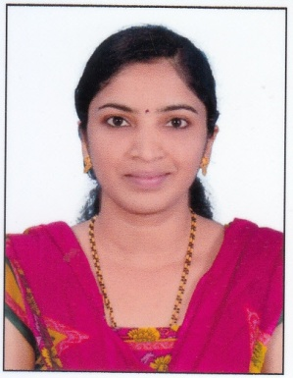
Deepa.351880@2freemail.com

Career Summary:-
Result oriented experience more than 4 years in Accounts, Taxation, expertise in Internal Audit, Statutory Audit and Tax Audit,
Objective:-
To succeed in an environment of growth and excellence and earn a job which provides me job satisfaction and self-development and help me achieve personal as well as organizational growth.

Area of Expertise:
- Internal Audit.
- Sox Audit
- Statutory Audit
- Tax Audit
- VAT Audit

Work Experience:

Audit Trainee:
CA Prabhakara Maiya P Kundapura. From March, 2008 to Sept 2011.

Account and Audit Assistant:
K.S. Hegde & Co. Kundapur. From June 2007 to September 2007.

Roles and Responsibilities

I. Internal Audit:
1. Preparing audit plan, frame work, documentation, and communication with experts and reporting to Management.
2. Evaluates and provides reasonable assurance that risk management, control, and governance systems are functioning as intended and will enable the organization’s objectives and goals to be met.
3. Reports risk management issues and internal controls deficiencies identified directly to the audit committee and provide recommendations for improving the organization’s operations, in terms of both efficient and effective performance.
4. Engages in continuous education and staff development.
5. Evaluates regulatory compliance program with consultation from legal counsel.
6. Physical verification and reporting on same.
7. Reporting to management with recommendation and actions to be undertaken for effective internal control in place.

II. Statutory Audit:
- Audit as per the Companies act.
- Financial statement analysis and review.
- Reporting CARO requirement.

III. Tax audit:
- 44AB reporting and checking and verifying 3CD with annexure.
- Filing companies Income Tax return within due date.

IV. Vat audit:
- Filing VAT return with the due dates and working the purchases and sales T.O and the VAT calculation in the books and as per return and reporting on variances.

V.VAT, Exercise, Service tax:
- VAT Return data preparation, filing VAT return, upload purchase and sales details to VAT website, checking the entries, challans month/six month wise and reporting on the delayed payments if any with interest and penalties.

VI. Bank Audits:
- Concurrent audit &amp; Income Audit of Corporation Bank, corporation bank.

VII. Interaction:
- Ability to deal with clients and can enrich my knowledge & utilize my potential optimally with organizational interest as priority & follow best professional standards.

Major Audit Assignments:
- KVAT Audit
- Tax and Statutory Audit.
- Statutory compliances
Professional Qualification:
Qualification | Year of passing
CA Final Ist Group | May-2013
CA PCC | May-2011
CACPT | FEB-2008

Technical Skills:

- Tally version.

- MS Office, Excel and Power point.

- Compulsory computer training course as per ICAI requirement.

Personal detail:

- Date of Birth: 20/09/1986
- Marital Status: Married
- Languages Known: English , Hindi, Kannada

I hereby declare all the above mentioned statements are true and correct to best of my knowledge.

