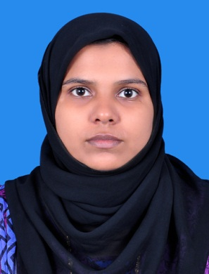
FAHISHA
FAHISHA.351907@2freemail.com

Career Summary | To take up a challenging career in a reputed concern, where I can explore and enhance my skills as a key team member, making an important contribution to the financial health and strategy of the institution.
Career Objective | To build a challenging career as an Expertise Professional in an Organization that offers exciting opportunities to learn & contribute to Organizational Goals.
Total Professional Experience | - 6 months of Professional Experience in software developer field.  From June 5th 2016 – December 30th 2016  - 2 years of teaching experience in a English Medium School as a Math’s Teacher  From 2011 June to 2013 March
Area of Expertise | Computer Science, Mathematics
Knowledge & Experience | - Having strong skills in teaching and seminar presentations.  - Having good knowledge in areas of computer science and mathematics.  - Object Oriented Programming.
Technical Qualification | - Software Testing, Software Development Life Cycles.  - Having strong skills in Database programming & Basics in My SQL.  - Programming language: Basics of Visual basic, C, C++ and Java.  - MCA; Post Graduation in Computer Application [year of passing: 2016]  CCSIT Kuttipuram, Calicut University, India  - BSC in Computer Science [year of passing:2011] Majlis Arts and Science Collage, Calicut University, India
Previous Employer | - Ociuz technologies pvt ltd, Thrissur, Kerala, India  - Darussalam English Medium School, Kadavu, Thiruvegappura, Kerala, India
Key Skills | - Possess excellent verbal and written communication skills.  - Possess good management and organizational skills.  - Possess strong presentation and analytical skills.  - Utility Software: Microsoft office (Word, Excel, PowerPoint)  - Inter Personal Skill  - Optimistic and dedicated
MAJOR PROJECTS HANDLED

PROJECT 1: PROTECTION OF DARK INFORMATION WITH STEGANOGRAPHY
Description: In PROTECTION OF DARK INFORMATION WITH STEGANOGRAPHY an advocate management system is used to demonstrate Steganography. Steganography is used to protect client information from various attacks. Here the system allows user is to select a public image for applying steganography on a confidential file.

PROJECT 2: IT DIRECTORY

Description: Develop an IT Directory Web Site as part of a mini project in my MCA Degree. Here a user can find a best company to develop his desired software solutions. Here a user incorporates different software development companies, project centers and freelancers along with different options to filter which in deed result in a best company for each user.

 | PERSONAL INFORMATION
Date of Birth: | 08– May - 1989
Nationality: | Indian
Marital Status:  Spouse: | Married  Yusuf c
Languages Known: | English, Malayalam
DECLARATION

I hereby declare that the above furnished particulars are true to the best of my knowledge and belief.

