CURRICULAM VITAE
Habibat
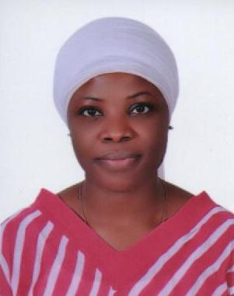

HABIBAT.352002@2freemail.com

Personal Information | Date of Birth : 01-Oct-1983  Nationality : Nigerian  Gender : Female  Marital Status : Single
Objective | A presentable, articulate, motivated, confident and well groomed individual with approved ability to work excellently to my perfection as my objective in the company, with passion and love to deliver the best services ever. I have a methodical, customer – focused approach to work and a strong drive to see things completed. I am seeking for a challenging position where my diverse experience in customer care arena will b fully utilized in order to become part of the company’s quest for success.
Experience | Auians Company in Nigeria (2011 to 2012)  (Office Cleaner)  - 1 year of extensive experience in cleaning and janitorial capacities.  - Highly skilled in cleaning, waxing, buffing and dusting.  - Demonstrated ability to work efficiently with other crew members.  - Able to take direction from supervisors.  - Enthusiastic to perform all physical aspects of the cleaning job duties.  Happy Junior Cairo (2012 to 2016)  (Office Assistant).  - Responsible for all aspects of the day to day running of the filing, copying, report writing, and invoicing jobs.  - Responsible to handle the telephone enquiries.  - Make daily work plan of seniors with proper timing.  - Provide general information to the customers.  - Manage the daily incoming of the customers.  - Manage the documents in proper way.  - Handle all the other responsibilities related to the job
Education | - High School Diploma.
Other Skills | - Flexible and strong team player who prospers in fast paced environment.  - Excellen customer service skills, good interpersonal and relationship skills.  - Very strong writtend and spken communication skills.  - Ability to deal tacfully with upset or angry passengers.  - Ability to work on tight deadlines, follow and act on instructions.  - Ability handle a flexible work schedule at any time.
Language | - English (Written and Spoken) and Arabic (Written and Spoken).

