CURRICULUM VITAE
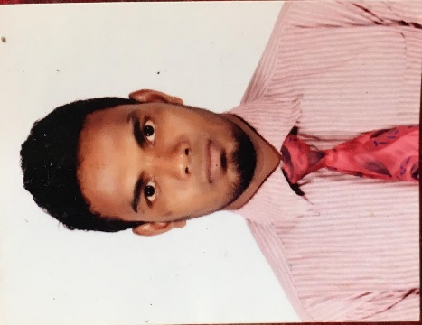

Objective
To secure a promising position that offers both a challenge and a good opportunity for growth.

Experience
Working in various Company’s and Department.
ORGANIZATION | FROM | TO
Spinneys Abu Dhabi LLC | 2014 | At present
Pepsi co(varun beverages lanka) | 2012 | 2014
Lee impex textiles | 2009 | 2011

- Customer service asst and merchandiser in spinneys 2014 to up to date.
- Sales representative and credit collector at pepsi co varun beverages lanka
- Customer service assistant and sales man at lee impex textile

PRESENTLY WORKING AT SPINNEYS ABU DHABI AS A customer service representative cum merchandiser SINCE - 2014
- Giving a good service to the customer.
- Maintaining the daily basis recodes.
- Doing monthly GP stock count and After Yearly 4 times main stock count.
- Take care about customer complains.
- Maintaining the display.
- Checking the order sheet and the delivered items.
- Maintains the warehouse and store recodes and document.
- Fulfill the customer expectation and needs.
- Making quick decision at any issues.
- Doing merchandise and maintain the display.
- Increase the customer base.

Works and responsibility at pepsi co varun beverages lanka pvt ld
- Doing customer service by visiting the route daily.
- Talk to the customer and taking the orders.
- Promoting the product to the new customer.
- Making invoice and collecting the credits from the customer.
- Maintaining the records and documents.
- Achieving the monthly targets.
- Doing supplying the product to the customer.
- Maintain the relationship with the customer

EDUCATIONAL qualifications (COLLAGE)
- I passed GCE O/L (Ordinary Level) 2008 at Bluemandhal Sinhala vidyalaya

relevent skills and experience
- Average computer knowledge.
- Good in customer service.
- Excellent team work skill.
- Ability to perform under pressure & deadline target.
- Self –motivated and assertive.
- General knowledge in sap system.

LANGUAGES SKILLS
- Excellent writing & Communicating in English.
- Excellent writing & Communicating in Sinhala.
- Fairly communicating in Hindi.
- Excellent understanding &communicating in Tamil.
- Fairly communicating in Malayalam

Personal information –
DOB : 19/04/1991
Gender : Male
Civil Status : Single
Religion : Islam
Nationality : Sri Lankan

I DO HERE BY CERTIFY THE ABOVE MENTIONED PARTICULARS ARE TRUE & CORRECT TO THE BEST OF MY KNOWLEDGE.

