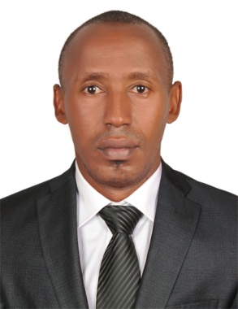
CURRICULUM VITAE

NAME:James

James.352038@2freemail.com

PERSONAL PROFILE
- Gained excellent experience in hospitality within career to date.
- Confident communicator and ability to remain calm under pressure.
- Proactive, organised and forward thinking.
- Attentively at all times with a willing and helpful manner that is required to answer phone calls, taking reservations and prepare bills.
- Always approachable, cheerful and posses good observation skills as well as the ability to work alone or as part of a team.
- Certified pool lifeguard.

SKILLS

Interpersonal skills Effective listening skills

Strong organisational skills Strong problem solving skills
MS Office Record Keeping, Report Writing, Observation skills

Excellent communication skills . Adaptability – Able to work round the clock.

CAREER HISTORY

Nov2012 – Aug 2016 Galsheet Kenya ltd

Store keeper

- Opening and closing gates of stores and warehouses.
- Daily stock taking and maintain of stock reports.
- Checking incoming and out going goods.
- Maintain general cleanliness of stores .
- Checking goods coming in and going out.
- Prepare of delivery reports for goods going out.
- Receive of goods and confirm quality and quantity.
- Enforce the FIFO system.
- Prepare the purchase requisition and and local purchase orders
- Process local delivery oders and invoices
- Check material for leakages and expirey dates
- Follow on LPO and deliveries
- Maintain safe stock levels
- Countercheck on stores requisition
- Prepare monthly stock reports
- Call suppliers and negotiate on cost of items
- Maintain safety standards as per ISO CERTIFICATION
Jan2010-dec2011 Silver springs hotel

POOL LIFEGUARD
- Open and close the swimming pool
- Observe andorganise pool activities
- Enforce policies and regulations of the pool
- Provide emergency care when need arises
- Be on the lookout for any distress calls
- Keep records and reports on pool activities
- Confirm and check chlorine and a waters PH is to required standards
- Report any incidences to management
May 2006 – DEC 2009 GALSHEET KENYA LTD
Sales representative

- Promotion of the company’s products and services.
- Daily delivery of Company Customer Service Standards; building strong and trusted relationships.
- Assist clients with their enquiries solve the client’s queries; retain their business, whilst promoting further range of products.
- Complete internal handover procedures for both new and existing clients.
- Expanding the customer base within the commercial sign sector on a national basis.
- Prospect potential customers in writing, by phone, and in person and effectively outline the company’s products and services.
- Maintain a database of all prospected opportunities, contact details and status of sales activity.
- Ensure all sales activity reports are reviewed, analyzed, and followed up as appropriate.
- Maintain all client contract, and agreement documentation to the relevant standard.
- Communicate with accounts, and sales departments, to ensure that all new clients are set up and ready for business in a timely and correct manner.
- Build partnerships with key personnel and ensure queries and problems are resolved promptly with all relevant parties.
- Work with the sales team in the refinement of pricing strategies
- Support the sales team as required by communicating any gaps in point of sales materials.
- Perform any other duties as required by the management

- EDUCATION
AUG 2013 – DEC 2013 YMCA Kenya
Lifeguard Certification

JAN 2005- APRIL 2006: Africa Nazarene University
Diploma in Purchasing and supplies management

JAN 1989 – DEC 1993: Kangaru High School
KCSE attained

REFEREES

Provided upon request

