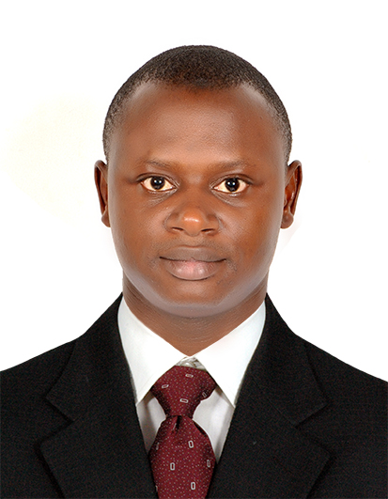
ATUH
ATUH.352042@2freemail.com
PROFILE : MALE, 32 MARRIED

PROFILE: Extremely motivated and well qualified medical lab technician with 6+ years’ solid experience in diverse lab settings. Well versed in drawing samples that require minor incisions and conducting chemical analysis. Demonstrated ability to work efficiently in a busy lab in an organized manner. Registered as a Medical Laboratory Technician with the CAMELS and DHA . Specialized courses in Hematology, Microbiology, Biochemistry, Parasitological, blood bank, Serology.
HIGHLIGHTS OF QUALIFICATIONS
• Skilled in medical lab technician tasks including sample collection, analysis and lab report production
• Well versed in laboratory software and digital reporting
• Knowledgeable of state approved medical lab policies, hygiene requirements and general/standard procedures
• Track record of collaborating with pathologists and physicians regarding test results and analytical patterns in blood reporting

SELECTED ACCOMPLISHMENTS
• Attuned and standardized all laboratory equipment at a new outlet of medical laboratory, ensuring set-up of separate work stations for microscopic studies, blood work, chemical analysis and bacterial studies
• Trained 20 plus employees in Med-tech and digital report processing systems to improve over-all productivity of the lab
• Centralized and integrated the medical reports system and enhanced report retrieval efficiency by 50%

Strong knowledge of ISO. International Organization for Standardization.

PROFESSIONAL EXPERIENCE
L’HOPITAL PROTESTANT DE BONABERI CAMEROON | 2013/2016 – Present
Medical Lab Technician
• Analyze various samples that come in for chemical testing and generate the relevant reports
• Supervise over-all quality control in the medical lab ensuring sample collection in properly sterilized containers and maintain analysis instruments functional and up to date
• Post and record full day’s record in the medical lab software before closing up each evening
• Implement and maintain standard medical lab policy guidelines in the lab
Islamic University Medical Centre Medina, KSA | summer 2011/2013
Medical Lab Tech
• Performed automated routine and special blood tests
• Drew samples from patients personally when needed
• Issued timely and accurate reports based on analysis
Institute Of Science And Technology IST Clinic Bamenda I 2006/ 2009
Medical Laboratory Supervisor
- Organizes work by matching computer orders with specimen labeling; sorting specimens; checking labeling; logging specimens; arranging reports for delivery; keeping work surfaces clean and orderly.
- Maintains quality results by running standards and controls, verifying equipment function through routine equipment maintenance and advanced trouble shooting; calibrating equipment utilizing approved testing procedures; monitoring quality control measures and protocols.
- Serves as technical resource by participating in staff training; answering questions of other professionals; participating in educational opportunities; reading professional publications; maintaining personal networks; participating in professional organizations.
- Identifies and communicates abnormal patient conditions by alerting supervisory personnel, the pathologist, the patient physician, or nurse; reporting mandated information to the public health department or other designated officials.
- (Toxicology) identifies the presence or quantity of drugs of abuse, therapeutic drugs, and toxic substances by operating toxicology instrumentation and performing manual methods for the performance of drug screens, blood alcohol levels, and carbon monoxide levels.
- (Chemistry) provides test results for patient diagnosis and treatment by operating chemistry equipment; performing hand chemistries.
- (Hematology) provides test results for patient diagnosis and treatment by operating hematology, urinalysis, and coagulation equipment; performing manual methods of differentials.
- (Immunology) provides test results for patient diagnosis and treatment by operating equipment such as the gamma counter, spectrophotometer, densitometer, and through methods such as radioimmunoassay, enzyme immunoassay, and serological testing.
- (Microbiology) provides physician with information for treatment of patient infection by performing technical procedures for the identification or susceptibility of bacteria, parasites, fungi, and mycobacterium.
- (blood bank) ensures the patient of receiving compatible blood/blood components by completing blood typing, antibody screening, compatibility testing, and antibody identification procedures.
- (blood bank) assures future retrieval of patient transfusion information by preparing patient packets and maintaining blood bank database.
- Contributes to a safe and secure environment for patients, visitors, physicians and co-workers by following established standards and procedures; complying with legal regulations.
- Maintains patient confidence by keeping laboratory information confidential.
- Serves and protects the hospital community by adhering to professional standards, hospital policies and procedures, federal, state, and local requirements, and jcaho standards.
- Enhances laboratory services and hospital reputation by accepting ownership for accomplishing new and different requests; exploring opportunities to add value to job accomplishments.

EDUCATION AND LICENSURE
Medical Laboratory Technician DIPLOMA [ Institute Of Science and Technology Bamenda 2006. B.Sc in HEALTH SCIENCE state University Cameroon 2013.
CLT ( Certified Lab Technician 2011)
SKILLS: Micro soft words, internet, etc
Language: Arabic, English and French.

