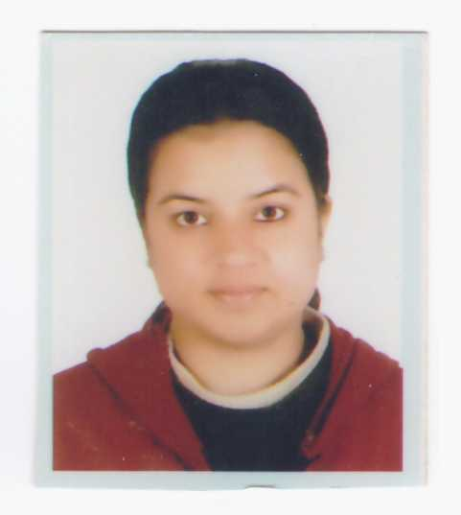
Ganga
Ganga.352084@2freemail.com

Career Objective

To obtain a position in a Health care facility where I can utilize my knowledge, skills and experiences to provide quality health care.

Work Experiences

The Health Medical Services L.L.C Al Ain April 2016 to till date

HAAD RN

Major Responsibilities
● Co-ordinate with family and patient to develop home care plans
● Assist in daily living of activities like bathing ,eating ,walking ,transferring
● Monitor vital signs along with blood sugars using glucometer
● Administer medicines through different route
● Prepare nursing assessment and reports on patients progress
● Establish patient's goals and home care requirements
● Evaluate and implement home care plans for patients

Shree Birendra Army Hospital Nepal July 2011 to April 2016
OFFICER NURSE

AREA: Post Operative ward , Maternity, Gynae and obstetric

Post operative Nurse

Major Responsibilities
●Assessing a patient's condition with planning and implementing patients care plan.
●Perform different procedures likeBed making ,checking vital signs,assist in ambulation.
Positioning
Prepare ,administer and record prescribed medications.Report adverse reaction to medications or other treatments.
● Provide post operative care according to needs(wound care, ostomy care, catheter care, tubes care, oral care,pain management)
●Prepare ventilator and assist doctors during intubation,treatment and procedures which can include life saving situations.
● caring pt with ventilator
● Helping doctors in cvp insertion, making rounds with doctors and nurses

Cases Handled :
● Ortho cases: Total hip replacement, subluxation, external fixator, internal fixator
● Gynae cases: laparatomy, hysterectomy with bilateral salphingoopherectomy, vaginal hysterectomy
● ENT cases: septoplasty, Tonsilectomy, polypectomy
● Uro cases: TURP, lithotripsy, nephrectomy
● Neuro cases: VP shunt, craniotomy
● Gastro cases: cholecystectomy (laparoscopic and open), laparatomy, Whipple's procedure, appendectomy, colectomy , ileocolectomy, ileotomy

Maternity Nurse

Major Responsilities
● Receive the patient with detailed history(LMP,EDD,previous ANC visits, any danger signs, patients' complain of)with available investigations reports.
● Perform the physical examination(vital signs, FHS,contraction,P/A examination,P/V examination,cardiotopography).
● Inform the duty doctor about the case.
● Admit the patient according to stage of the labour. Provide patient care according to the need of the patient.
● Assist,encourage,support the patient during labour or during operation. Monitor patient's progress using partograph during labour.
● Antenatal ,Intranatal and postnatal care.

Cases handled :
● Antenatal cases in different stages of labour,IUFD, Pre eclampsia, Eclampsia, Pacenta previa, abruptio placenta.
● Conduting normal delivery and scrub nurse and circulatory nurse in caesearen section.

Gynae/Obstetric Nurse

Major Responsibilities
● Receiving patient from maternity, post operative ward ,Emergency and Gynae Opd. Checking vital signs, general assessment of patients condition, newborn babies.
● Encouraging and supporting for breastfeeding and different positioning styles along with burping technique.
● Performing procedures like dressing, stitches removal, tubes removal, perineal care. Carry out treatment protocol ,opening IV line, providing IV ,IM,S/C medicines.
● Prepare pt for OT, care after operation, giving education.

Cases handled
● Postnatal cases with episotomy , tear, with vaccum delivery. Post caesearen section cases along with new born babies.
● Pregnant cases with different diagnosis like UTI ,fever ,hyperemesis gravidarum, decrease fetal movement ,fall injured, threatened abortion,missed abortion, incomplete abortion, ectopic pregnancy, molar pregnancy.
● Gynae cases like utero vaginal prolapses, abnormal uterine bleeding, dysfunctional uterine bleeding,fibroid uterus,adenaxal masses.ca ovary,ca cervix, dermoid cyst, chocolate cyst.
● Post operative Gynae cases like laparatomy, hysterctomy with bilateral salphingoopherectomy, vaginal hysterctomy, suction and evacuation.

Trainings

●Helping Babies Breathe Master Trainer Course on August 2012
●Basic Life Savings organised by American Heart Association on July 2015

Academic Qualifications

Bachelor of Science in Nursing (B.Sc Nursing) - Bachelor Degree
Dates : December 2006-December 2010(4 years course)
Principle Subjects :Integrated Health Sciences , Fundamentals of Nursing , Community
Health Nursing , Nutrition and Diet Therapy , Adult ,Child and
Geriatric Nursing , Midwifery , Family and Reprodutive Health

Nursing, Nursing Concepts Theory , Psychiatric Nursing
Board Name : Tribhuvan University
Institute Name : Institute Of Medicine , Nursing Campus , Maharajgunj , Kathmandu
Nepal

10+2 Science - Intermediate Degree
Dates : June 2003- June 2005
Principle Subjects : Physics , Chemistry , Biology , Mathematics , English
Board Name : Higher Secondary Education Board
Institute Name : Millenium HIgher Secondary School, Palpa , Nepal

School Leaving Certificate (SLC)
Completion Year : 2002
Principle Subjects : English, Mathematics, Science and Computer.
Board Name : His Majesty Government , Nepal
Institute Name : Palpa Awasiya Secondary School , Tansen ,

License and Registration

●Helping Babies Breathe Master Trainer - August 2012
●Registered Nurse - Health Authority Abhu Dhabi, HAAD, Expires @ Apr 27, 2018
●Registered Nurse - Nepal Nursing Council, NNC, Nepal. Expires @ Jun 13, 2017
Language Skills

Languages | Speaking | Reading | Listening | Writing
English | Excellent | Excellent | Excellent | Excellent
Nepali | Excellent | Excellent | Excellent | Excellent
Hindi | Excellent | Excellent | Excellent | Excellent
Urdu | Excellent | Poor | Excellent | Poor
Arabic | Fair | Poor | Good | Poor
Computer Skills

Good Command in Microsoft word, Excel, Power point, Windows 98, Windows 7, Windows 8.1
Publication

Awarenes On Urinary Tract Infection Among Pregnant Women, a research report submitted to Maharajgunj Nursing Campus, Tribhuvan University for a partial fullfillment of B.Sc Nursing 2010.

