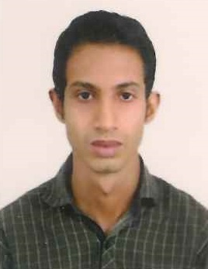
AHAMMED
AHAMMED.352089@2freemail.com

OBJECTIVE:
To work in a challenging environment in the IT field that could utilize my skills towards the growth of the esteemed firm/organization that can offer opportunities for professional growth.

EDUCATIONAL QUALIFICATION:

- Diploma in computer Science and Engineering from Institute of Electronics & Telecommunication Engineers [I.E.T.E] New Delhi, India for 3 years.
- Higher secondary (Computer Science) from Board Kerala, India

EXPERIENCE:
- Working as a IT Administrator in Al Shams Al Satheaa Internet Services, Sharjah, U.A.E from 14/04/2015 to till now.
- Internship with Try-Catch Technologies, Kerala, India for Six months
COMPUTER KNOWLEDGE:

Operating system : windows 98/XP/2003/7 server /windows8
Language : C, C++, C#
Application software : MS-Office 98/2003/2007, 2010, Open office
Software engineering : software process, software design, coding,
Web Package : HTML, VISUAL STUDIO 2010, 2012, 2015
Other Software’s : Adobe Photoshop

PROJECT:
- SOCIAL NETWORKING PORTAL WITH CHAT AND MESSAGE FOR TIME SHARING
This project will be a desktop application to be developed in C#&.Net having SQL server as backend
AREA OF INTEREST:

- Programming languages
- Software Engineering
- Computer Hardware and Networking

STRENGTHS:

- Sound and technical strength
- Flair for trouble shooting
- Friendly
- Committed
- Patient and ambitious
- Sincere

TYPE OF EMPLOYMENT DESIRED:
Preferably in an IT industry field under Software development, Programming and Networking section.

PERSONAL PROFILE:

Date of birth : 04/12/1989

Martial status : single

Nationality : Indian

Languages : English, Hindi& Malayalam

DECLARATION:

I hereby declare that all the details and particulars furnished above are correct to my knowledge.

