CURRICULUM VITAE  NIJO  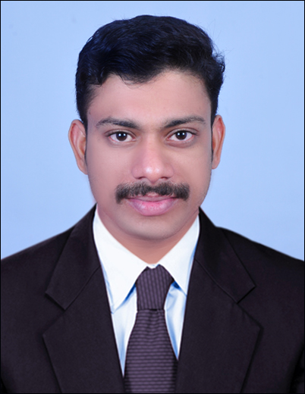  NIJO.352095@2freemail.com  Languages Proficiency:  English,Hindi, Malayalam & Tamil. | 0BJETIVE  To place myself in a responsible and challenging position and to employ my experience and skills in a progressive organization, whereby I can put maximum efforts and prove my skills to attain the heights in the job profile provided.  EXPERIENCE PROFILE  JUBILEE MISSION MEDICAL COLLEGE HOSPITAL  Position Staff Nurse  Duration 02.08.2010 to 02.03.2015.  Department MALE MEDICAL WARD  Address Bishop Alapatt Road, P B No: 737,  Thrissur Dist,Kerala,India.  KEY STRENGTH  - Profound knowledge of general nursing and critical nursing practices  - Can asses pharmacologic and non-pharmacologic treatment of health problems.  - Ability to prioritize and develop plans accordingly.  - Proficiency to educate patients and their families in compliance with the hospital rules and regulations, patient's rights, etc.  - Ability to function independently.  - Strong managerial and organizational ability.  - Multi tasking ability not compromising with the quality of work.  ROLES  Assisting in the supervision and development of health care assistants.  Assessing the care needs of patients.  Effectively collaborated with doctors regarding patients’ test results, treatment protocols and issued recommendations subsequent to condition changes.  Prepared patients for procedures, both physically and emotionally.  Provided care to individuals before, during and after procedures.  Development, implementation and evaluation of programmers of care  Performing administrative duties.  Reporting to senior managers.

DETAILED JOB DESCRIPTION

- Receiving and admission of patients
- Data collection
- Assessment of vital signs
- Physical examination and diagnostic evaluation
- Continuous monitoring of patients
- Following physician rounds and carrying out the orders described
- Assisting for diagnostic and therapeutic procedures
- Planning and implementation of patient care includes hygiene, nutrition, comfort measures and elimination needs
- Administration of medications
- Health education
- Discharge and follow-up care
- Maintaining records and reports
- In service education

MANAGERIAL SKILLS

- Orientation for patients and relatives about the hospital and its functioning
- Maintenance of environmental hygiene
- Preparation of emergency drugs and emergency trays ready for use
- Asepsis and infection control
- Maintenance of records and reports
- Maintain ward inventory and intendeds

ACADEMIC PROFILE

BACHELOR OF SCIENCE IN NURSING (BScNURSING )
DURATION : 4 Years (August 2005 – September 2009)
AWARDING BODY : Rajiv Gandhi University of Health Sciences, Karnataka.
INSTITUTION : Royal College Of Nursing, Banglore, Karnataka.

HIGHER SECONDARY EDUCATION

DURATION : 2 Years (June 2003 - March 2005)
AWARDING BODY : Board of Higher Secondary Examination, Kerala, India.
INSTITUTION : S.R.K.G.V.M.H.S.S. Puranattukara, Thrissur, Kerala, India.

SECONDARY EDUCATION

YEAR : 2003
AWARDING BODY : Kerala State Board of Secondary Education.
INSTITUTION : St.John’s H.S. Parappur, Thrissur, Kerala, India.

OTHER PARTICAPATIONS

BLS AND ACLS

YEAR : 2016
AWARDING BODY : American Heart Association
INSTITUTION :Redefine Advanced Academy for Nurses, Thrissur,

HEALTH AUTHORITY-ABU DHABI

YEAR :2016
APPLICATION
SPECIALITY :Registered Nurse on visit visa

COMPUTER PROFICIENCY
- Familiar with Windows Operating System
- MS Office
- Internet surfing and e-mail operations

TECHNICAL PROFILE

EQUIPMENT USED | ASSISTED IN | PROCEDURE DONE
- ECG machine.  - Pulse oxymeter.  - Glucometer.  - Syringe pump.  - Infusion pump.  - Suction apparatus.  - ABG machine.  - Nebulizer.  - Gas Cylinder.  - Ophthalmoscope.  - Transfusion Kit. | - Lumbar Puncture.  - Liver biopsy.  - Abdominal Paracentesis.  - Paracentesis Thoracis. | - CPR.  - NG Tube insertion.  - I.V insertion.  - Blood transfusion.  - Prone Ventilation.  - Blood withdraws.  - Foleys catheterization.  - Flatus tube.

DECLARATION

I do hereby declare that the statements made above are complete and correct to the best of my knowledge and belief. Kindly grand me an opportunity to serve your esteemed organization and I assure you my best performance.

