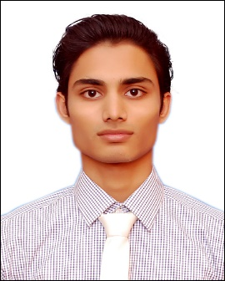
Muhammad

Muhammad.352104@2freemail.com

OBJECTIVE

I am a highly disciplined and responsible individual, smart and well presented with pleasant and cheerful disposition and communication skills. I can work independently and as part of a team to obtain and welcome challenges that would enable me to advance both personally and professionally growth. My objective is to gain valuable experience in a professional environment which would add value to the business of organization.

PROFESSIONAL WORKING EXPERIENCE

Rehan Electronics as a Sales Executive Sep 2013 to Feb 2014

- To achieve weekly and monthly targets.
- Deals in all mobiles brands and mobile accessories.
- Deals with small mobile dealers and prepare daily sales report.
- Maintain petty cash.
- In the month visited 8 to 10 customer for the repayment amount.

Life Line Medical Center as a Assistant Accountant Nov 2014 to March 2015

- Handle petty cash amount.
- Make salary sheet.

ACADEMIC QUALIFICATIONS
Degree | Institution | Passing Year

Metric (Science Group). Karachi Board, Karachi Pakistan. 2011
Intermediate (Pre-Engineering). Karachi Board, Karachi Pakistan. 2013
Diploma in Computer Software and IT. Aptech Computer Education, 2017 Karachi, Pakistan.
SHORT COURSES

- Sales and Marketing.
- Front Desk Training.
- Client Handling Training.
- Human Resources/Public Relation.

SKILLS

- Proficient in MS Office, with hands on experience in MS Word, MS Excel.
- Exploring the internet for research purposes.
- Quick learner and problem solver.
- Client handling.
- Convincing power by communicate.
- Hard working and dedicated.
- Highly adaptable with strong interpersonal skills.
- Team player.
LANGUAGES

- English
- Urdu

PERSONAL INFORMATION

Nationality : Pakistani
Marital Status : Single
Date of Birth : 14th Nov 1994

