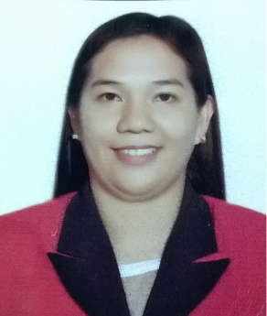
JHOANNE
JHOANNE.352112@2freemail.com

Jhoanne is committed to her work, dependable and can be counted upon to finish what she started, eager to learn, explorer, friendly, cooperative, hardworking, energetic, responsible, approachable, honest and responsible to pursuit of a challenging and rewarding opportunity of employment.

EDUCATIONAL BACKGROUND:
Bachelor of Science Major in Office Management
Notre Dame of Tacurong College, Philippines
March 2012
WORK EXPERIENCE:
Tacurong Fit Mart Mall, Philippines (June 2012-June 2013)
Sales Officer
- Promoting and selling products
- Work with customers with the most cheerful and pleasant disposition
- Give answers to customers’ questions or concerns related to the product they are charged to sell.
- Communicate and assist customers in any way possible and as the customers may require
- Deal with customer’s complaints professionally and with restraint
- Process or help process payments made by the customer – whether by in cash or credit card
- Report sales accurately
Cherubim United Methodist Learning Center. (June 2013 – July 2016), Philippines
Administrative Assistant
- Supports administrative and/or accounting operations by filing documents and record keeping
- Update and maintain accounting journals, ledgers and other records detailing financial business transactions (disbursements, expense vouchers, receipts, accounts payable, invoices, and delivery receipts).
- Served also as school clerk
- Facilitates enrollees
- Answer and direct phone calls
- Assist in the preparation of regularly scheduled reports
- Order office supplies
- Provide general support to visitors

Sales Representative-Global Village(November 1, 2016- April 8, 2017)

- Promoting and selling products
- Dealing with customer needs.

SKILLS:
- Adaptability
- Collaboration
- Strong Work Ethic
- Time Management
- Self-Confidence
- Handling Pressure
- Leadership
- Creativity

\

PROFESSIONAL REFERENCES:
Available upon request

