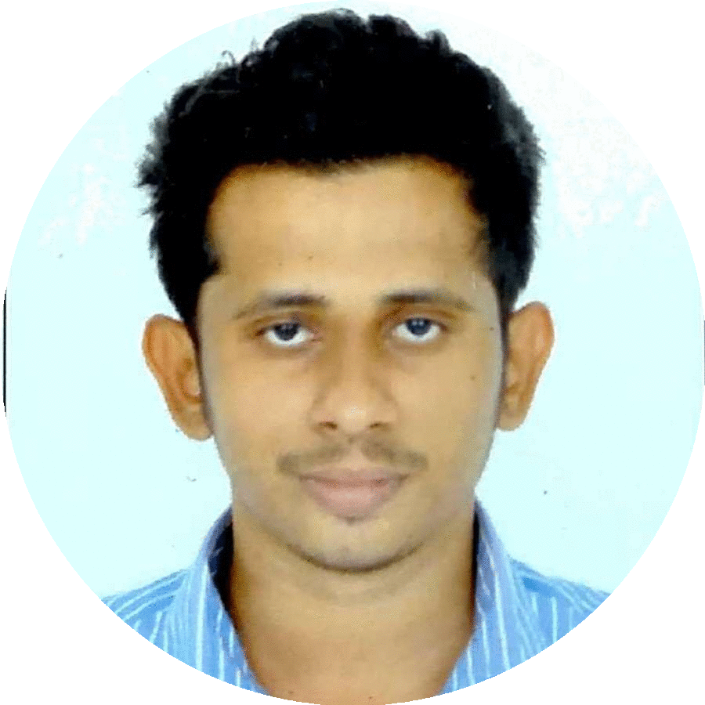
Husainar
Husainar.352124@2freemail.com

✴
About Me
I am a dedicated ,reliable ,responsible and hardworking person having 2+ years of experience in Information technology.My goal is to obtain a challenging opportunity that contributes the outstanding success of the business and allows me to utilize my skills and experience .

 | ✴
 |  | SKILLS  WEB DEVELOPMENT  DATABASE MANAGEMENT  HARDWARE SUPPORT  TEAM HANDLING | APPLICATION SUPPORT  HOSTING SUPPORT  NETWORK SUPPORT  DOMAIN SERVICES

✴
EXPERIENCE

JUNIOR SOFTWARE ENGINEER LIGHTDAY TECHNOLOGY.
COCHIN,KERALA, INDIA — JANUARY 2016 – JANUARY 2017

JOB PROFILE :
- Read and Understand Software Requirments.
- Design , Develop and Maintain Application Programs in PHP.
- Create Frontend using javascript ,html,bootstrap,css jquery.
- Cordova mobile application development.
- Develop Database Scenario.
- Develop application program interface for mobile application.
- Content uploading and hosting management.
- Test and Fix bugs.
- Rapidly establishing a good working relationship with customers and other professionals.
- Bringing problems and concerns to the owner/manager in time for effective action to be taken.

Works Completed :
- Rabah Group ERP System.
- Clinic Management System.

- SVD Mission Mobile Applications.
- Jobsfortheday Mobile Application.

Technical Support Officer Local Government Backoffice
KASARAGOD,KERALA , INDIA — JULY 2011-MAY 2012

JOB PROFILE :
- IT Service Desk- System installation, application support and end user support .
- Manages Windows network (users, computers, printers, etc.)
- Install and support LANs
- Periodically Backing Up Database.
- Implementation and administration of DNS, DHCP.
- Linux System administration.
- Application supports. Hardware Support
- Configuring and Troubleshooting Email Clients; Microsoft Outlook.
- Assist in IT Procurement Activities.
- Implementing and Installing, Printers , Scanners , Modems etc.

TECHNICAL KNOWLEDGE

- Good understanding of operating system concepts.
- Knowledge in Linux System.
- Familiar with Cisco Devices and configurations, CCNA.
- Experience in OOP Programming.
- Experience in Database Queries and its administration.
- Familiar in MySQL, Oracle Databases
- Good knowledge core java concepts and java web pages.
- Experience in PHP core Programming.
- Experience in PHP Framework CodeIgniter.
- Experience in WordPress and Joomla frameworks.
- Experience in Angular JS.
- Experience in Mobile App Development Ionic Framework and Cordova.
- Good Knowledge and Experience in HTML, CSS3, Bootstrap and JavaScript Web concepts.
- Knowledge in Microsoft Active directory
- Proficient in Microsoft word and power point.
- Knowledge in SEO Principles.
- Experience in computer peripherals management and troubleshooting.
- Good typing Speed 40 WPM(English).

✴

EDUCATION QUALIFICATION

MASTER DEGREE / POST GRADUATION
MASTER OF COMPUTER APPLICATION (MCA)
Kannur University , Kerala Government
Year - 2012-2015.

DEGREE / GRADUATION
BACHELOR OF SCIENCE in COMPUTER SCIENCE (BSc Computer Science)
Kannur University , Kerala Government
Year - 2008-2011

INTERMEDIATE
+2 in computer Science
Kerala Government Education Board
Year -2006-2008

SCHOOL
SECANDARY SCOOL LEAVING CERTIFICATE
Kerala Government Education Board .
Year 2006.

STRENGTH
✴ Communication Skills ,Flexibility and Adaptability ,Quick Leaner ,Dedicated and Responsible.

LANGUAGES
English: (Speak,read,Write)
Hindi: (Speak,read,Write)
Malayalam: (Speak,read,Write)
Arabic: (Read,Write)

I hereby declare that particulars given above are true and best of my knowlwdge and belief.

