DANISH
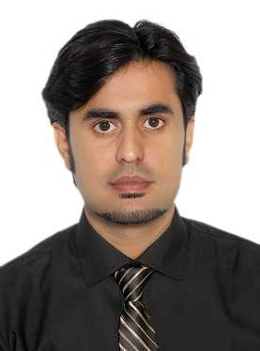

DANISH.352130@2freemail.com

Other Information
Date of Birth 1st Jan 1989
Nationality Pakistani
Marital Status Married

Objective:

To pursue a career at a leading organization, where I can exhibit my abilities and offer my services to further the business objectives of the organization and at the same time learn from the
Experience.
Experience:

5 Years Experience as a Customer Support Executive

- 2 Years UAE experience with Awok.com -Dubai
Online business (www.awok.com)- Technical Support Department
- 2 Years experience with Wateen Telecom Limited, Pakistan -Lahore
TRG-The Resource Group Lahore Pakistan, Technical support department.

- 6 Months Sales| EFU Life insurance Company, Pakistan
As a sales consultant.

- 6 Months telesales|Eleven Soules,Lahore,Pakistan
Canadian project for duck cleaning or security alarm system
Qualification:

B.B.A (Honors)
Bachelor Business Administration Marketing Year 2008-2012
Superior group of colleges Lahore Pakistan

Intermediate
FSC Pre-Engineering Year 2006-2008
Baluchistan Instituted of Technology

Matriculation
Computer Sciences Year 2004-2006
Federal Government Public School Quetta
Experience of AWOK.COM-DUBAI,UAE:

Position-Technical Support Backkup Supervisor

Responsibilities:
- Organizing workflow and ensuring that employees understand their duties or delegated tasks
- Pass on information from upper management to employees and vice versa
- Prepare and submit performance reports
- Hire and train new employees (Venus India)
- Ensure adherence to legal and company policies and procedures and undertake disciplinary actions if the need arises
- Monitoring employee productivity and providing constructive feedback and coaching
- Setting goals for performance and deadlines in ways that comply with company’s plans and vision
- Receive escalations and resolve them
- Maintain timekeeping and personnel records

Position-Technical Support Executive -CSR

Responsibilities:
- Troubleshooting steps to diagnose the error and provides First caller resolution FCR
- To check the exact errors in item, claim the warranty accordingly.
- To schedule Pick & Drop
- To provide best solution to the callers regarding their complaints.
- To provide guidance to the callers regarding their Problems.
- To make a customer support report of each caller in detail during handling the call.
Experience of TRG -Wateen Telecom Limited -Lahore,Pakistan:

Responsibilities:
- Retain customers
- Providing Promotional offers
- Resolve issue in services
- Courtesy Calls
- Dealing with Escalations
- Reporting
- Maintaining K.P.I.
Additional Skills:
- Daily Shift Reports

- Computer literate
- Command on Microsoft Office
- Hard worker or work committed.
- Interpersonal Skills: Adaptability to changing environments and ability to develop good relations with co-workers. Patience to listen and understand other’s viewpoint.
- Leadership Skills: Ability to influence and lead others and getting the required job done within the allotted time.
- Language/Communication Skills

Reference will available upon request.
Interests:

