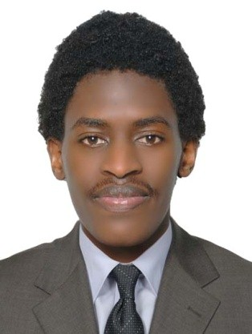
AKRAM

Akram.352131@2freemail.com

SALES EXECUTIVE

Personal Summary
I am a results driven, committed and articulate sales executive with excellent communication skills and a high level of customer commitment. I am multi-skilled with the ability to plan and manage territory whilst and maintaining & developing existing and new customers through ethical sales methods and consistent high customer service. I also do possess a good team spirit, deadline orientated and having the ability to succeed in a demanding sales environment.
Now looking forward to making a significant contribution in an ambitious and exciting company that offers a genuine opportunity for progression.
WORK EXPERIENCE:
Sharaf dg
Sales Executive: 2014 May 10 – Present
I attend the customers who enter the store, assess their requirements then sell to them the company’s products and services that match their needs and provide solutions which are required for its particular use. I am also responsible for providing after sales services which enables me to create and maintain good relationships with new & existing customers respectively in order to foster long lasting and repeated business.

DUTIES:
- Working as part of the sales team to provide good services for new and existing customers.
- Identifying Customer needs and then providing the perfect product with the best solution.
- Involved in developing sales and pricing strategies.
- Listening to Customers to answer and resolve their queries.
- Evaluating competitor activity and developing appropriate responses through the market survey.
- Writing accurate and informative sales report and documentation.
- Collecting all the information from customers required to increase sales and customer satisfaction hence generating sustainable growth.
- Doing Cashiering in case of a big footfall in the store

TOKYO 35 CLOTHING BOUTIQUE
Sales Associate 2011-2013
Speak Resort Hotel
- Receptionist 2010-2012

KEY SKILLS AND COMPETENCIES
- Ability to hit targets: I am always determined and hardworking which has enabled me to achieve most of my monthly targets hence resulting to getting 90% in my 2016 annual appraisal.
- Strong Communication skills: I am a good listener which enables me to easily create a good conversation with customers and i also speak audibly.
- Negotiation skills: I regularly get involved in series of negotiations of small and big deals within the store with different customers on a daily basis which i have gotten used to and has enabled me to always close 90% of deals I get.
- Presentation skills: I always illustrate to the customer how the product their purchasing is used by telling them about the features and the benefits they get from them.
- Ability to work under minimum supervision due to experience acquired.
- Excellent planning and organization skills.
- Ability to upsell and convert customers new and existing in order to close a deal.
- Computer skills which include networking and Microsoft office usage.

EDUCATION BACKGROUND:
Education:
Institution | Degree(s) or Diploma(s) or Certificate(s) obtained:
2011-2012Taibah International school | Uganda Advanced Certificate of Education (U.A.C.E)
2007-2010: Greenhill Academy | Uganda Certificate of Education (UCE)
2000-2006: City parents School | PLE Certificate

REFRENCES:
Available upon request.
AMBITION
Looking forward to expand my career in the sales industry. I will be so grateful if my application is put into consideration.
Am available on the above telephone and address if chance is granted.

