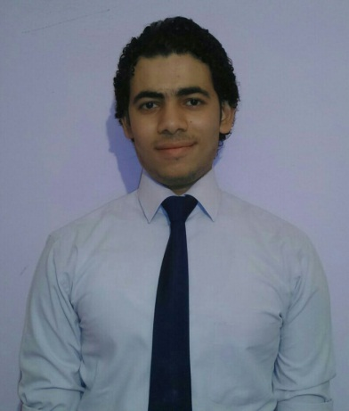
PERSSONAL INFORMATION:
- Name: Gohary
Marital: Single.-
- Birth day: 15\10\1990
Religion: ISLAM -
- Nationality: Egyptian
- E-mail Address: gohary.352151@2freemail.com

EDUCATIONAL QULIFICATION:
-Qualification: Bachelor of languages &translation-Al Azhar University
-Department: Spanish language -Estimate: Above Average
-Graduation Year :2012
-Diploma in tourism guidance -Egoth Institute for tourism and hotels
In 2016.
LANGUAGES:
-Arabic: Native -Spanish : Fluent -English : Good
Work Experience
-I worked as a Tour leader “Spanish language” on Faraon travel in Egypt for two years. (2013-2014)
-Iam working as a hotel reservation agent (call center) on Stream global service “expedia account ” "Spanish language " from April 2014 till now.
Spanish Translator on Matrix for translation
Spanish Tourist Guide
Personal Skills
Mastering all the computer skills (ICDL).
-An enthusiastic; qualified; hard worker; and so good team player hope to get the chance to be one of your professional staff.
-Before everything; I need gain more and more experiences; by your work system.
-Excellent communication skills. -Excellent in build relationship with people.
-Ability to work well under pressure.
-Ability to work extra hours.
Thank you
I hope and wish to join your team work.

