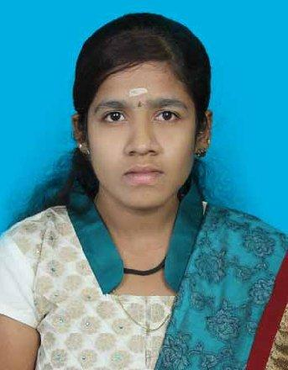
BHUVANESWARI.

Email id: bhuvaneswari.352166@2freemail.com

CAREER OBJECTIVE

- My experience in customer support will help to utilize the same to the best of my caliber and result oriented approach for the growth of organization and self.

- An unwavering commitment to customer service, with the ability to build productive relationships, resolve complex issues and win customer loyalty.

- Strategic-relationship/partnership-building skills -- listen attentively, solve problems creatively, and use tact and diplomacy to find common ground and achieve win-win outcomes.

WORKING EXPERIENCE

1. Protection Services Executive PayPal,Chennai Nov 2015 to till date

Responsibilities:

Participated in pilot groups and provide feedback and solutions or ideas to improve department efficiency.

Placed pending reversals and limited access when appropriate.

Resolved PayPal customer complaints, claim appeals and limited access accounts in

Attack after reviewing information and documents provided by customers.

Assisted in department special projects as needed to improve customer satisfaction using discretionary decision making skills.

Proficient in resolving counterfeit claims by following company and brands specific policies.

Reviewed fax documentations including

- CAF Activation Officer at Vodafone South Ltd., October 2014 to August 2015

Responsibilities:

Receiving the CAF(Physical file), Which is filled manually by the retailer \ distributor with POI and POA.

Receiving CAF’s systematically through admin and validate the CAF using POI and

POA.

Once CAF is activated, SIM will get activated to the network.

Have to check the authentication of POI and POA(based on Central and State Govt

Guide Lines )

Needs to report to the Line manager daily basis with EV reports ,Pending activation reports and CAF rejection Report.

Maintaining the MPN requesting between Distributor and retailer.This all should be done with stipulated AHT(activation timing target).

- Customer Service Executive at CMC Limited April 2013 to June 2014

Responsibilities:

- Examined passport applications for completeness of information.

- Determined whether passport applications should be accepted or denied.

- Reviewed citizenship documents for validity.

- Examined oath and all signatures.

- Corresponded with applicants regarding passport decisions.

- Requested more information or issued denials with directions for additional needed documentation.

EDUCATIONAL QUALIFICATION

- Master of Computer Application (2010-2013), with 83% from Srinivasan Engineering College, Perambalur.

- Bachelor of Computer Application (2007-2010), with 76% from Chidambaram Pillai College for Women, Mannachanallur.

- Higher Secondary (2007), with 76% from The Government Girls Higher Secondary School, Srirangam.

- SSLC (2005), with 60% from the Government Girls Higher Secondary School, Srirangam.

EXTRA-CURRICULAR ACTIVITIES

Attended the one day seminar in Mobile Computing from Dhanalakshmi Srinivasan College of Engineering

Second class in Government Technical exams (type Writing Lower) Attended Three days health camp through NSS club

Languages Known – Tamil and English

PERSONAL DETAILS

Name | : | Bhuvaneswari
Gender | : | Female
Marital Status | : | Single
Nationality | : | Indian
DOB | : | March 20th 1990
 |  | DECLARATION

I hereby declare that the information and facts stated above are true and correct to the best of my knowledge and belief.

SIGNATURE

( Bhuvaneswari)

