Bilal

Bilal.352188@2freemail.com

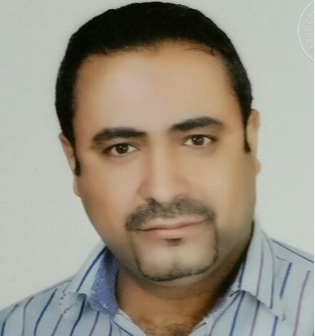

20 years of Hospitality and customer service experience in 5 stars’ hotels and restaurants in Jordan and UAE, handle paper's work, handling complains, make training for the staff, and make sure the rules of my company are our goals beside guest satisfied.

Career History

- Zaroob Restaurant UAE, Jan 2016 till Mar 2017 as a Restaurant Manager.

- Automatic Restaurant and Grill, UAE, Dubai, feb 2014 till Dec 2015 as a Branch Manager.

- Al Makan Restaurant, (Al Koufa Services) UAE, Dubai, 2011 till 2012 as a Asst. Rst. Manager:

Responsible for managing the daily operations of our restaurant, including the selection, development and performance management of employees. In addition, they oversee the inventory and ordering of food and supplies, optimize profits and ensure that guests are satisfied with their dining experience. Reporting to the Restaurant Manager/food and beverage manager.

- Burj Al Hamam, (BinHendi Enterprise) UAE, Dubai, 2008 till 2010 as a Restaurant Supervisor - Opening staff:

Supervising the staff, make communication between dining and kitchen, make training the staff under the company rules, control the inventory, maintenance, suppliers, follow the hygiene of the staff.

- Marriott Hotel, Jordan, Dead Sea, 2005 till 2008:

Ensure that you give exemplary hospitality to the guest at all times, To ensure that orders of food and beverage are served promptly in accordance with company standards, To report all faults to the in charge, take orders...etc.

- From 1997 till 2005:
- Movenpick Hotel, Jordan, Dead Sea.
- Four Seasons Hotel, Jordan.
- Le Royal Hotel, Jordan, Amman.
- Panorama Hotel, Jordan, Petra.
- Mamamiah Restaurant, Jordan, Amman

Training & QUALIFICATION

- High School - Jordan - Zarka 1998.
- Micros system.
- Up Front guest care skills training.
- Up Front Food and Beverage service skills training.
- Up-selling Training.
- Food& Beverage Standards.
- Passport to Success Level 7 (Marriott Hotel).
- Mystery Shopper Letter 100% (BinHendi Enterprise).
- Fire training.
- ICDL.

OBjective
To work in multinational dynamic and challenging establishment with scope for learning further growth and major development and make my goals my new company goals with team spirit between me and all staff members.

SKILLS
- Microsoft Windows.
- Microsoft Office.
- Excellent Command of all Internet skills.
- Ability to work under pressure.
- Ability to work long hours.
- Ability to work in team.

