Muhammad.352206@2freemail.com
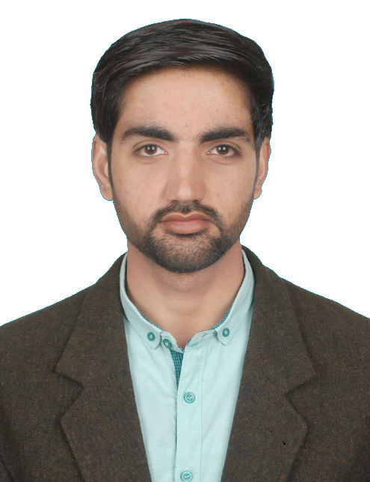

Objective:

To obtain a suitable position in an esteemed organization, where I can utilize my qualification and experience to carry out my duties efficiently and develop a successful career.

Professional Experience
Store Keeper/Inventory Controller April, 2009 till Dec, 2016
Leather Field (Tanning Unit) Pvt Ltd (Sialkot, Pakistan)
Duties & Responsibilities
Material Inward:

- Collect the Challan from Security gate and cross check the Security inward Register.
- Check the Materials of make, model, brand, & sizes, and quantity.

Documentations:

- Prepare GRN In ERP. System & Ledger Register on day to day basis.
- Prepare weekly Pending List for the material not received against the Indent raised.
- Audit the physical balance with the Ledger Register balance on every month
- Raise Rejection slips for rejected items.

Supervision & Control:

- Control material ordering by checking the Indent and apprise the engineer regarding the availability of the material at site.
- Supervise, assist and train stores assistant in his day-to-day work.
- Check the Gate pass, Transfer Notes, Issue Slip.

Material Outward and Logistics:

- Appraise the Site In-charge and Purchase dept. regarding the scrap accumulated at site.
- Ensure that the requiring site produces proper approved Transfer Note and only then transfer the same.
- Accompany the vehicle to check the measurement at weighbridge.

Reports:

- Monthly Report (Inventory of materials on monthly basis)
- Preparing daily follow-up material status as per instruction by Site In-charge
- Weekly Materials Pending Reports.

Knowledge in IT & E.R.P System:

- ERP Entry of Indent.
- ERP Entry of Goods Received Note (GRN) & Issue Note
- Find Purchase Orders & Checking in ERP
- Store related all works in ERP system.
- Microsoft Word, Excel, PowerPoint, Internet Browsing – Email Related Utilities.
- Knowledge in Computer Hardware
- Typing 30 wpm

Expert in:
- Customer Relationship Account Handling
- Store Reporting Record Keeping
- Store Management Store Analyses

Academic Detail:

(B.Com) Bachelor of Commerce with 2nd Division from AIOU Islamabad, Pakistan
(D.Com) Diploma in Commerce with 2nd Division from PBTE Lahore, Pakistan
(SSC) Secondary School Certificate with 2nd Division from BISE Gujranwala, Pakistan
(HAR) 3 Months Diploma in Home Appliances Repair with A+ Grade from PBTE Lahore, Pakistan

Personal Information:
DOB Dec 20, 1987
Marital Status Single
Gender Male
Religion Islam

Declaration:

"I hereby declare that the above mentioned information is true to the best of my knowledge and belief"

