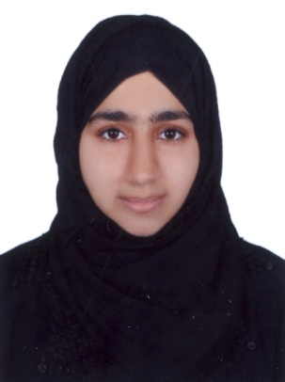
Curriculam Vitae
Rabia
Rabia.352242@2freemail.com

- Objective:
To use my skills and potential in taking up challenging assignments in order to enhance my career from an early start, and also contributing to the growth of the organization as a whole. My skill set presented from school and ahead are the promise of a good match for the job requirements. Likewise, My aim would also be

- To submit my duties with complete dedication
- To obtain profound skills to further enhance my capabilities, and
- To be sincere to achieve my goals with hard work and distinction

- Skills:

- Challenging responsibilities
- Energetic and excellent communication & interpersonal skills.
- Result oriented with experience Customer Relation management.
- Easily adaptable new environment.
- Data Entry Skills, Typing.
- Quick learner

- III.ACADEMIC QUALIFICATIONS:

- Institute: Cyprus Institute of Marketing (Ajman, UAE)
Currently Attaining a Degree in B.Com (Bachelors In Commerce)

- Institute: Al Amaal English High School (Sharjah, UAE)
Higher Secondary School Certificate (I.Com)

- Institute: Al Amaal English High School (Sharjah, UAE)
Secondary school Certificate (Computer Science)

- PROFESSIONAL EXPERIENCE:

- 1.Organization: Little Red rose Nursery(Sharjah -UAE)
Position: Assistant Teacher

Duties & Responsibilities:

- Getting The class room ready for lessons.
- Listening to children read,reading to them or telling them stories.
- Helping children who need extra support to complete task.
- Helping teachers to plan learning activities and complete records
- Supervising group activities.
- Encouraging younger children to learn through play.
- Helping with outings and sports event.
- Carrying out routine administration task.

- 4.Organization: Al Ansar international School
Position: Reception/telephone operator

Duties & Responsibilities:

- Input data into operating system.
- To greet all the visitors and colleagues.
- To provide visitors and colleagues with accurate directions & information.
- Handling all incoming and calls.
- Perform typing and clerical tasks.
- Sending and receiving all the mails & faxes.
- Assist students and others with routine problems.
- Assists in all aspects of maintaining a professional front office.

- Technical skills Technology:

- Word Processor Microsoft Word.
- Spread Sheet Microsoft Excel.
- Information System Internet, E-mail.

- Languages:

- English
- Urdu
- Arabic
- Hindi

- Personal Profile:

- Date of Birth :12th Nov 1991
- Place of Birth :Dubai
- Marital Status :Single
- Visa Status :Residence (Mother’s Sponsorship).
- Religion :Islam
- Nationality :Pakistani
- Gender :Female
- License :Unavailable

- Interest and hobbies:

- Travelling
- Reading
- Writing
- Sports
- Browsing Web

Declaration:

I hereby Declare that the above said facts are true to the best of my knowledge and belief.

