SUDEESH  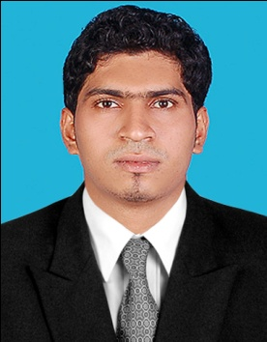  SUDEESH.352250@2freemail.com  Personal Profile  Date of Birth :19th April 1990  Gender : Male  Nationality : Indian | CURRICULUM VITAE  Career Objective  To work in a challenging environment and obtain professional excellence in career position within an organization, which offers good advancement opportunities and effectively utilizes my skills which I have acquired.  Personnel Skills  - Self motivated with excellent communications skills  - Self correspondence with creative ideas  - Well organized, hardworking and result oriented.  - Punctual and able to adapt to different environments & systems  - Ability to grasp any work quickly  - Resourceful, initiative and ability to work under pressure  - Aggressive, confident and trustworthy  Work Experience  Accounts Executive DEC 2014-DEC 2016  CHARISHMA Hotels, BANGALORE  - Assisting the seniors in Audit Accountant.  - Took part in the Audit of various accounts.  - Preparation of books of accounts.  - Checking of daily Accounts details.  Academic Qualifications  - MBA - FINANCE, MARKETING(2012-2014), Kannur University  - B.B.M (2008-11), MANGALORE UNIVERSITY  - Higher Secondary- SCIENCE (2006-08)  - 10th CBSE (2006)  Technical Qualifications  Operating System : Windows 7, Windows XP  Application packages : MS Office, Tally  Extra Curricular Activities
Languages Known
- Speak : English, Malayalam, Hindi and Kannada.
- Read & Write : English, Hindi.

Projects Undertaken
- ‘FINANCIALPERFORMANCE ANALYSIS’ at AKG Hospital, Kannur (FINANCE) for 2 months.
- An overall ORGANISATIONAL STUDY at Kerala State Civil Supplies Corporation, Ernakulum for 1 month.
- Industrial visit at KITEX, ANNA ALUMINIUM.

Extracurricular Activities
- Active member of AIM’s club during MBA
- Member of University cricket team.
- Higher Secondary School Cricket team Captain.

Hobbies

- Listening music, net surfing etc

DECLARATION

I do hereby declare that the particulars given above are true to the best of my knowledge and belief.

