Mubashar
Mubashar. 352251@2freemail.com
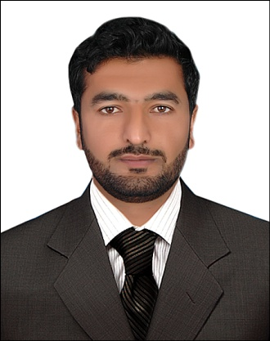

AIMS & OBJECTIVE:
To work in a dynamic and challenging organization where I can elevate my professional skills and abilities and utilize those for securing benefits for the organization and my own self.

ACADEMIC PROFILE:

(1) BS-CS (hons) Preston University Islamabad Pakistan.
2012spring - 2015fall (CGPA= 3.4).

(2) FSC (pre­medical) AJK Mirpur board of higher secondary education.

(3) Matriculation (science) from AJK Mirpur board of secondary education.

SKILLS:
- Installation
- Hardware
- Software
- PPT
- Excel
- Microsoft Office.
- Internet and Email.
- Management(MIS)

WORKING EXPERIENCE:
➢ Worked with SDPI (sustainable development policy institute) as MIS Intern from
November-28- 2016 to December-27- 2016
➢ Worked as an internee with Alcatel Lucent July-10- 2014 – September-9- 2014
➢ Worked as a translator with Cuban Doctors Nov 2005 - March 2006

INTEREST
● Computer Networks
●Telecommunication
●IT
●Public Relation
●Wireless networking
●Optical Networks
●Public speaking
●Management
● MIS
●Artificial Intelligence

PROJECTS:
● 3D printer working Industries

- Robotic Arm Development
- Natural Gas Production
- IT security system
- Fiber Optics Networks
- LAN Network Establishment
- Internet Security

TECHNICAL PROFICIENCIES:

Languages:

- Urdu
- English
- Arabic (learner)
- Spanish (beginner)
- Hindko
- Punjabi

Strengths:
- Capable of working in tense conditions and deadlines.
- Very keen interest in playing and studying games.
- Excellent written and verbal communication skills.
- Can get use to new environment and software
Very quickly,
Ability to learn and adapt very quickly(Self Learner).

COMMUNICATION SKILLS & PERSONALITY
- Enjoying a confident, optimistic and pleasing personality.
- Enjoying excellent communication skill both in English and Urdu.
- A quick learner with skills, hard working, motivated, devoted to the tasks given and likes to accomplish things in the best possible approach.
- Ability to work in teams.
- Responsibility towards the accomplishment of assigned tasks.
- Analytical Skills, Communication Skills and Time Management.
- Quick learning ability with dedication.

SPORTS:
Cricket all rounder, in Islamabad, region.

Reference:
References are available on request

