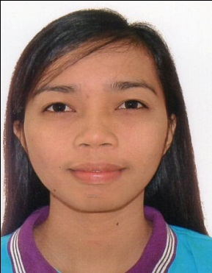
Gladys

Gladys.352253@2freemail.com

ADMINISTRATION PROFESSIONAL

A reliable, devoted, knowledgeable, flexible and result-oriented individual. Able to do multi-tasking, handle pressure, work in a fast-paced and self-directed environment, and most importantly work as a part of a team. Excellent in verbal and written communication skills.
EMPLOYMENT EXPERIENCES

DEPARTMENT OF SOCIAL WELFARE AND DEVELOPMENT Cebu City, Philippines
Program Administrator April1, 2014 – December 31, 2016

- Coordinate with local authorities for all the logistical processes needed for the posting of beneficiary lists in the public places, validation of information, signing oath of commitment, Land Bank forms and ID preparation for the conduct of community assembly/ registration for beneficiaries
- Plan and organize the provision of Family Development Sessions for beneficiaries according to the prescribed modules by the NPMO
- Provide Orientation and training to parent leaders and LGU Links at the municipal/city level on the conduct of family development sessions, use of update forms and grievance and complaints form
- Keeps detailed records of enrollment and attendance to family development or parental sessions
- Provide inputs and clarifications to parent leaders and beneficiaries about the program including their duties and responsibility and rights under the program
- Facilitate, review and submit to Operations Unit or Regional Level completed update forms, CVS forms and GRS forms (when necessary) for encoding and processing
- Keep log books detailing dates of presentation of complaints and updates and other transactions made by the beneficiaries
- Inform beneficiaries of the results of the grievances, complaints and updates and of other matters raised by beneficiaries including parent leader
- And perform other related tasks that may be assigned.

PASSERELLES NUMERIQUES FOUNDATION INC. PHILIPPINES
HUMAN RESOURCE ASSISTANT JULY 4, 2013 - March 30, 2014

JOB DESCRIPTION:

- Assist with day to day operations of the HR functions and duties
- Provide clerical and administrative support to Human Resources excutives
- Compile and update employee records (hard and soft copies)
- Process documentation and prepare reports relating to personnel activities (staffing, recruitment, training, grievances, performance evaluations, etc.)
- Coordinate HR projects (meetings, training, surveys, etc.) take minutes
- Deal with employee requests regarding human resources issues, rules, and regulations
- Assist in payroll preparation by providing relevant data (absences, bonus, leaves, etc.)
- Communicate with public services when necessary
- Properly handle complaints and grievances procedures
- Coordinate communication with candidates and schedule interview
- Conduct initial orientation to newly hired employees
- Assist the recruiters to source candidates and update the data base

Baccalaureate Degree
EDUCATIONAL ATTAINMENT

Mindanao State University Marawi City, Philippines
BS Social Work
REGISTERED SOCIAL WORKER
Current CGPA: 1.80 APRIL, 2013
PERSONAL DETAILS
Nationality : Filipino
Date of birth : May 24, 1993
Height : 5’0”
Weight : 99 lbs.
Visa Status : Visit Visa
Visa Expiration : April 29, 2016

