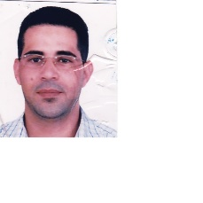

FIRAS
FIRAS.352273@2freemail.com

PERSONAL DATA

- Nationality: Palestinian/Tunisian

- Sex & Marital Status: Male, Married

EXPERIENCE

English Language Teacher

2005... 2016 Al Nahda National School Abu Dhabi

. Teaching English as a foreign language (10, 11 & 12 H.S).

EDUCATION

1997...2001 Lebanese University Tripoli, Lebanon

. Bachelor in English Language & Literature - Lebanese University - Dean of Faculty of letters and Human Science (Third Branch)

2000... 2004 Aouzaei Islamic College Beirut, Lebanon

Bachelor in Islamic Studies

LANGUAGE

-English Write, read & Speak Fluently
- Arabic Write, Read & Speak Fluently

RELATED COURSES
- ICDL Certificate
- Abu Dhabi Educational Council Teaching License-
- IELTS
- TOEFL
- SANID SAFETY & EMERGENCY COURSES (LEVELS 1-2-3-4)

