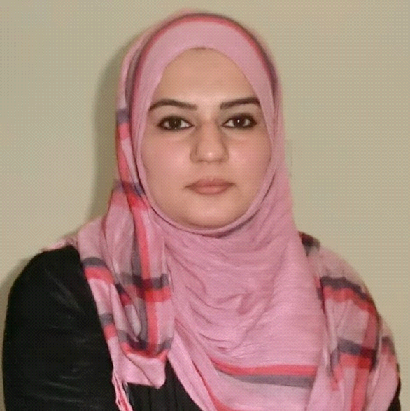

Assia
Assia.352302@2freemail.com
(Urdu Teacher)

Areas of Expertise

KG to Level 5 Special Education British Curriculum

Objectives

As a highly self motivated individual with strong professional record and multidimensional personality, I am seeking my next position in an organization where I can build my career as Assistant Teacher.

Qualification
M.A URDU University of the Punjab 2009

B.Ed (Islamic studies, Education) AIOU, Islamabad 2009

B.A (Islamic studies, Arabic) University Of Punjab, Lahore 2007

Intermediate (Arabic, Islamic studies) Rawalpindi Board 2003

Secondary School Certification Govt. High School, Rawalpindi 2001

Professional Skills & Experience

Al Maarah Nursery, Sharjah Served as Assistant Teacher

Trading company, Dubai Served as Office Assistant

Special Education Center, Pakistan Served as Teacher for Physical Handicaps students

The Radiant Public School, Pakistan Served as Islamic Studies teacher

IT Skill

- Proficient in MS Office (Excel, PowerPoint, MS Word)
- Intensive email and web browsing.

.

Languages

- English
- Urdu
- Hindi
- Punjabi
- Arabic ( Average )

Visa Status

- Currently on Husband visa, Sharjah.

