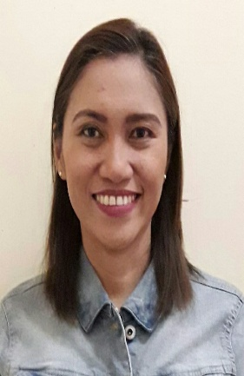

FLORENCE FLORENCE.352353@2freemail.com

Profile
- To be one with your company’s corporate philosophy in achieving success, growth and development in the years to come. Where I can use my experience, skills and education to help the company meet and surpasses its goals.
- Proficient in computer/software, Internet and E-mail tools.

Summary of Qualifications
- More than 9 years experience of posting of accounts, bookkeeping and other accounting related works.
- Highly skilled in handling accounting works, specially the posting of cashbook and ledgers.
- In-depth knowledge in making income statement and preparation of statement of assets and liabilities.
- Proficient in MS Office, and experience in Peachtree.
- Fluent in English both oral and written communication.
- Able to multi-task effectively.
- Enthusiastic and positive in nature.
- Able to provide a good and excellent customers service relationship.

Work Experience:

Davao Rock Construction Company Davao City, Philippines
Accounting Clerk/Accounts Assistant
January 2008-December 2016

Key Function:
- To receive documents needed for posting of accounts.
- Daily cash examination on the cashier/disbursing officer.
- Performing internal audit of accounts.
- Closing of daily cash and non-cash transactions.
- Checking of daily issuance of cheques and other related transactions.
- Reconcile balances and discrepancies of customer accounts.
- Preparation of labor payroll.

Seminars and Trainings:
- Seminar on Electronic Statement of Receipts and Expenditures (June 2009)
- Procurement flow and property and supply management seminar ( April 2015)

Educational Background:

Bachelor of Science in Accountancy – October 1998
University of Mindanao, Bolton Street, Davao City, Philippines

Degree in Masters in Public Administration – October 2011
University of Mindanao, Bolton Street, Davao City, Philippines

