DRISCILLA
DRISCILLA.352356@2freemail.com

Career Objective
Provide excellent customer service that will exceed client expectations giving the organization loyal customers with repeat business that will eventually increase revenue and growth.

CUSTOMER SERVICE SKILLS
- 3+ years of experience in customer service
- Familiar with IMS system and practices.
- High level energy and enthusiasm from the first customer to the last
- Exceptional Telephone personality able to build rapport with every customer
- Independent and a solid team member with exceptional customer service abilities

PROFESSIONAL EXPERIENCE
Customer Service Executive, Golden Tulip Hotel Ghana, Jan 2013 – Aug 2015
Responsibilities

- Collect information from our potential customers on phone
- Greeting guests with a smiling face and giving them all the necessary information about the company
- Escort and or direct guests to the places they need to go within the company
- Connect customers to the correct department and executives
- Explore possible client’s sites and compile a list of potential clients for management execution
- Match clients to the correct department based on client requirements
- Communicate with clients via phone and email
- Build clients base by building a social networks through cold calling and referrals

Customer Service Executive, Lighthouse International Ghana, Mar 2012-Dec 2012
Responsibilities

- Point of contact between the company and prospective client
- Investigate client problems and find solutions
- Communicate with client via phone, email, or letter
- Provide scripts to read from during phone calls
- Compile and print reports on overall client satisfaction.
- Isolate and identify areas of improvement
- Work with management on client service initiatives
- Utilize social media to respond to client complaints and praise
- Market company products to prospective clients
- Resolve client queries in time

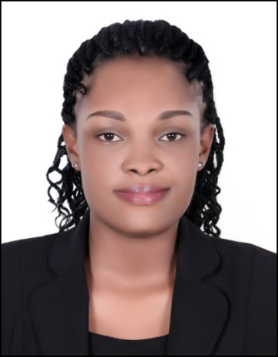

DATE OF BIRTH

19th 0ct 1991

PLACE OF BIRTH

Ghana

VISA STATUS
Visit Visa
MARITAL STATUS
Single

ACADEMIC QUALIFICATION

Bachelor of Arts , Industrial and Organisational Psychology (University Of Ghana-Legon, Ghana)

LANGUAGE PROFICIENCY

Fluent in English

TECHNICAL SKILLS
Ms Excel
Ms Word
Ms Power point

Hobbies: Travelling, Reading Books and meeting new people.

