CURRICULUM VITAE

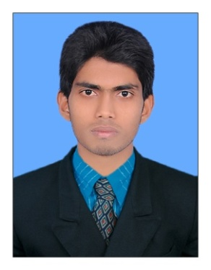
SAFEERALI

SAFEERALI.352376@2freemail.com

OBJECTIVE

To pursue a career in a well established organization utilizing my experience, qualification and skills to the benefit and excellence of the organization, with a desire to grow within the organization and be a good team player for the achievement of the organizational goals and objectives.
`
PROFILE

- High level of computer and internet literacy. Excellent in finding any information quickly.
- Exceptionally well organized, quick learner, keen attention to detail.
- Strong ability to remain objective and rational in tense or difficult situations.
- Open minded, coachable and willing to learn.

EMPLOYMENT EXPERIENCE

1, Role: Junior Accountant
Company: Geemas Wedding Centre, Vallapuzha
Kerala, India
Duration: From DEC 08, 2014 to FEB 27, 2017 (26 Months)
Software: Tally ERP9, MS Excel 2007

Responsibilities
- Preparation of Sales and purchase statements and submit to the senior department.
- Bank Reconciliation Statement.
- Preparation of day to day journal entries.
- Documentation of vouchers and invoices.
- Entry of Debit note and Credit note.
- Submitting Tax report to Senior Accountant.
- Posting adjustment entries.
- Preparations of Invoices like Sales, Sales Order, Purchase, Purchase Order etc.

TECHNICAL KNOWLEDGE

- Tally ERP 9
- Microsoft Excel 2007
- Peachtree
- Manual Accounting
EDUCATIONAL QUALIFICATION

Course | School/ University | Completed year
M.Com Finance | University of Kerala Distance Education- Part time | 2016
B.Com with Computer Application | University of Calicut | 2014
Plus Two(Commerce) | HSE Board of Kerala | 2011
SSLC | Board of Public Examination Kerala | 2009

LANGUAGES KNOWN

Language | Read | Write | Speak
English | Yes | Yes | Yes
Arabic | Yes | Yes | No
Malayalam | Yes | Yes | Yes
Hindi | Yes | Yes | No

DECLARATION

I hereby declare that the information furnished above is true to the best of my knowledge and belief.

