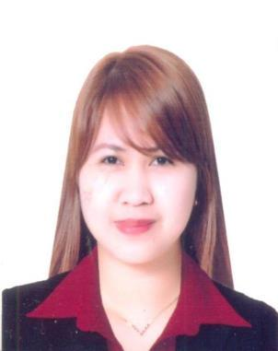

JANINE
JANINE.352382@2freemail.com

______________________________________________________________________________
Career Objective

Seeking a challenging work opportunity, while continuously aiming for self-improvement and performance excellence, to be able to significantly contribute to the achievement of the organization’s goals and objectives

______________________________________________________________________________

Highlights of Qualifications
- With high standards of work ethics and personal integrity

- Understands instruction with ease and carries them out effectively

- Confident self-starter, primarily interested in the achievement of tangible results and with a strong emphasis on getting things done right and quickly
- Microsoft office proficient

- Planning, documentation and record management skills

- Excellent customer service and interpersonal skills

______________________________________________________________________________

Employment History

Belhoul Speciality Hospital

Billing Assistant

June 23, 2015 – July 1, 2017

Job Profile
- Registering new patient. Doing patient admissions.

- Generating bills and collecting of payment

- Coordinating with other departments such as Insurance and Medical Department

- Taking insurance approval if necessary and confirming patients eligibility

- Doing shifting schedule as assigned, etc

Banco De Oro Universal Bank Inc.

Client Service Associate (Bank Teller)

August 16, 2013 – March 25, 2015

Job Profile
- Accept deposits, loan payments, process checking and savings account withdrawals

- Maintains the highest level of confidentiality with all information obtained.

- Promotes the bank’s products and services.

- Answer telephone and customer inquiries.

- Represent the Bank in a manner that maintains and expands positive relations with all customers, potential customers and co-workers.
- Perform as a team member in allocating and coordinating the work flow.

- Contribute to the fulfillment of department and company objectives and goals.

- Comply with all company policies, procedures and regulations.

BDO Private Bank Inc – Wealth Advisory and Trust Group

Office Clerk

January 21, 2013- July 5, 2013

Job Profile
- Collate all documents needed for audit presentation

- Response on audit issues and findings

- Review accounts of the client as well as submitted required documents

- Checking the completeness of the submitted required documents and Account Information Sheet and to encode them properly in the system

- Sending of provincial account statements and documents to a specific account holder ensuring confidentiality of the client.

- Other duties as assigned

______________________________________________________________________________

Educational Attainment

Lyceum of the Philippines University- Cavite

Bachelor of Science in Business Administration

Major in Operations Management; 2008 – 2012

______________________________________________________________________________

Seminars and Training Qualifications

Counterfeit Detection and Check Verification Seminar

By: BangkoSentral ng Pilipinas – East Avenue Quezon City; September 27, 2013

Signature Verfication Seminar

By: Mr. Jesus M. Belanio – BDO Karrivin Plaza; September 5, 2013

ID Detection and Fraudelent Check Verification Seminar

By: Mr Jefferson Devilleres – BDO Karrivin Plaza; August 27, 2013

Basic Cash Handling

By: Ms. Ana Roces – BDO Karrivin Plaza; August 22,2013

Understanding Customer’s Needs & Expectations / Customer Service Orientation

By: Ms. Ma Lourdes Zamudio – BDO Karrivin Plaza; August 16, 2013

______________________________________________________________________________

Personal Information

Date of Birth: April 26, 1992

Place of Birth: Makati City, Philippines

Citizenship: Filipino

Gender: Female

Civil Status: Single

______________________________________________________________________________

