Jahanzaib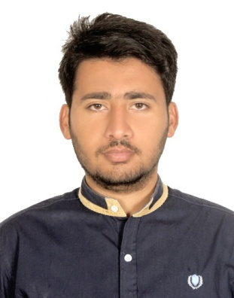
Jahanzaib.352395@2freemail.com

CAREER OBJECTIVE
To build a career with a leading corporation in marketing and mechanical sector. To explore myself fully, refine my skills and realize my potential, looking to work in a challenging and creative environment with other committed people.

ACADEMICS
DEGREE | YEAR | UNIVERSITY/COLLEGE | Division/Percentage
BS (Hons)  Economics | 2010-2014 | University of Gujrat | 1st/ (61.4 % )
Intermediate (FA) | 2009-2010 | Govt Commerce College | 1st/ (65%)
Matriculation | 2007-2008 | Govt. High School Jandanwala  Gujrat | 2st/ (55%)

WORKING EXPERIENCE
- Working As Sales Officer in ASKARI BANK PAKISTAN from May 2014 to July 2015
- Working As Assistant Manager at PIZZA HUT PAKISTAN from July 2015 to Dec 2015
- Working As Production Coordinator in SAFE MIX READY CONCRETE CO & UNITED ENGINERING CO (UNEC) UAE From January 2016 up to now.
Duties & Responsibilities
- Daily checked and order the needed equipment for manufacturing plant and sites.
- Daily report to branch manager about the current production of all plants.
- Very good knowledge of mechanical works and maintain about the plant machinery.
- Follow up the orders and its accuracy with the plant operators and site coordinator.
- Summarize the mix design with the technical department and ensure it in the local purchase order.
- Making production schedule for all batching plants and for customers.

PROFESSIONAL SKILLS
- Microsoft Office
- Microsoft Excel
- Technical Presentations
- Proposal Writing

LANGUAGES
- English
- Arabic
- Urdu
- Punjabi
HOBBIES & EXTRA-CURRICULAR ACTIVITIES

- Reading books
- Internet surfing
- Hiking and outdoor trips
- Volleyball

